

**Technical Design Document**

Project Name

ServiceNow

Prepared by

Issa Haddad

Osama Al-Madani

*Submission Date: 16th November 2016*

Contents

Overview 5

1 Creating/Updating incidents from Emails 6

Technical Solution 6

1.1 Create new or modify existing rules when receiving an email. 6

1.2 Enable sending/receiving emails from system. 6

1.3 Get your instance’s email address 7

1.4 Check received emails 7

2 Modifying form fields when conditions are met. 8

Technical Solution 8

2.1 Create new or modify business rules when conditions are met. 8

3 Creating Knowledge Article form Incidents 9

Technical Solution 9

3.1 Open any desired not closed incident 9

3.2 Publish Article. 9

4 Creating an inactivity monitor with email notification 10

Technical Solution 10

4.1 Setting up Inactivity Monitor 10

4.2 Connecting a notification to the inactivity Monitor 10

5 Closing an Incident Permanently 11

Technical Solution 11

5.1 Create an UI Policy to make state field read-only 11

6 Modifying Reports Headers and Footers 12

Technical Solution 12

6.1 Modify Reports Headers and Footers 12

7 Create link to reopen incident from Email 13

Technical Solution 13

7.1 Modifying required email template 13

7.2 Add email template to designated email notification 13

8 Auto populating task in case form 14

Technical Solution 14

8.1 Create a new workflow 14

8.2 Modify Workflow to add specific tasks. 14

9 Creating catalog item in customer Service portal with execution plan 17

Technical Solution 17

9.1 Adding the widget on customer service portal 17

9.2 Customizing categories for Customer service portal 17

9.3 Creating a Catalog item 17

9.4 Creating new Execution plan for your item 17

9.5 Creating new Execution Plan Task 18

9.6 Connecting new created tasks with the execution plan 18

9.7 Connecting new created Execution plan with the Catalog item 18

10 Creating an Account when a customer registration request is approved 19

Technical Solution 19

10.1 Widget 19

• Create a widget that allows customers to register. Cloning customer registration request is preferable as they are very similar. 19

10.2 Deactivate verification code-related business rules and client scripts 23

10.3 Create a new business rule to create a new account with each new contact 24

11 Asset management notes 25

Technical Solution 25

11.1 Use The Asset Management Overview module. 25

11.2 View assets that are in stock. 25

11.3 Create an Asset class. 25

11.4 Create hardware, software license, consumable, license, and facility assets. 25

11.5 Pre-allocated assets. 26

11.6 Split pre-allocated assets. 26

11.7 Fixed asset. 26

11.8 Add assets to fixed asset. 26

11.9 Sum the residual value of fixed asset. 27

11.10 Use depreciation. 27

11.11 Create license asset. 27

11.12 States and sub-states. 28

11.13 Asset-CI relationship. 28

11.14 Asset-CI mapping. 28

11.15 Create your own mapping. 29

11.16 Map asset state and CI install status. 29

11.17 Map asset state and CI install status. 29

11.18 Consumable asset. 29

11.19 View consumable assets. 29

11.20 Create consumable asset. 30

11.21 Consume a consumable asset. 30

11.22 Retire an asset. 30

11.23 Delete an asset. 30

11.24 Transfer Order. 30

11.25 Creating a transfer order. 31

11.26 Process of transfer Order (stage). 31

11.27 Asset in transfer order. 31

11.28 Delete order or line in draft stage only. 32

11.29 Return items received. 32

11.30 Create a stockroom. 32

11.31 Delete a stockroom. 32

11.32 Create stockroom type. 33

11.33 Stock rules. 33

11.34 Create new vendor/manufacturer. 34

11.35 Location module. 34

12 Creating Calendar in Homepage to show Changes 35

Technical Solution 35

12.1 Creating the report Calendar. 35

12.2 Customizing the report Calendar. 35

13 Creating Custom Applications 36

Technical Solution 36

13.1 Table creation. 36

13.2 Forms 36

13.3 UI policy. 38

13.4 Module form Studio. 39

13.5 Inbound Email Action. 39

13.6 Scripted REST API + resources. 40

13.7 Notes. 43

13.8 Project Module. 43

13.9 Incident Module. 45

13.10 Map Page. 46

13.11 Map Page Module. 46

13.12 Map Page Mobile Module. 47

14 System Theme Code 48

Technical Solution 48

14.1 Page with System Theme colour codes. 48

# Overview

Contents

This document is prepared to document the process of different functionalities available in Servicenow such as the ones described belw:

|  |  |  |
| --- | --- | --- |
| **S No.** | **Functional Area** | **Description (Business Requirement)** |
| 1 | Creating/Updating incidents from Email. | * Inbound email actions enable an administrator to define the actions Servicenow takes when receiving email. Inbound email actions are similar to business rules, using both conditions and scripts. The inbound email action checks the email for a watermark that associates it with a task and checks for other conditions. If the conditions are met, the inbound email action runs the script. * By default, if an email has no identifiable watermark, an inbound email action attempts to create a new incident from the message. If the email has a watermark of an existing incident, an inbound email action updates the existing incident according to the action's script. |
| 2 | Modifying form fields when conditions are met. | * A business rule is a server-side script that runs when a record is displayed, inserted, updated, or deleted, or when a table is queried. Use business rules to accomplish tasks like automatically changing values in form fields when certain conditions are met, or to create events for email notifications and script actions. |
| 3 | Creating Knowledge Article form incidents | * As an ITIL user, you can create a knowledge article when closing an incident or problem record. |

# Creating/Updating incidents from Emails

## Technical Solution

### Create new or modify existing rules when receiving an email.

* Navigate to System Policy 🡪 Email 🡪 Inbound Actions
* Click New, or modify an existing record.
* In this form it is possible to set the keywords needed to exist in an email to be processed as an incident-related.
* Populate Fields in the form as shown below:

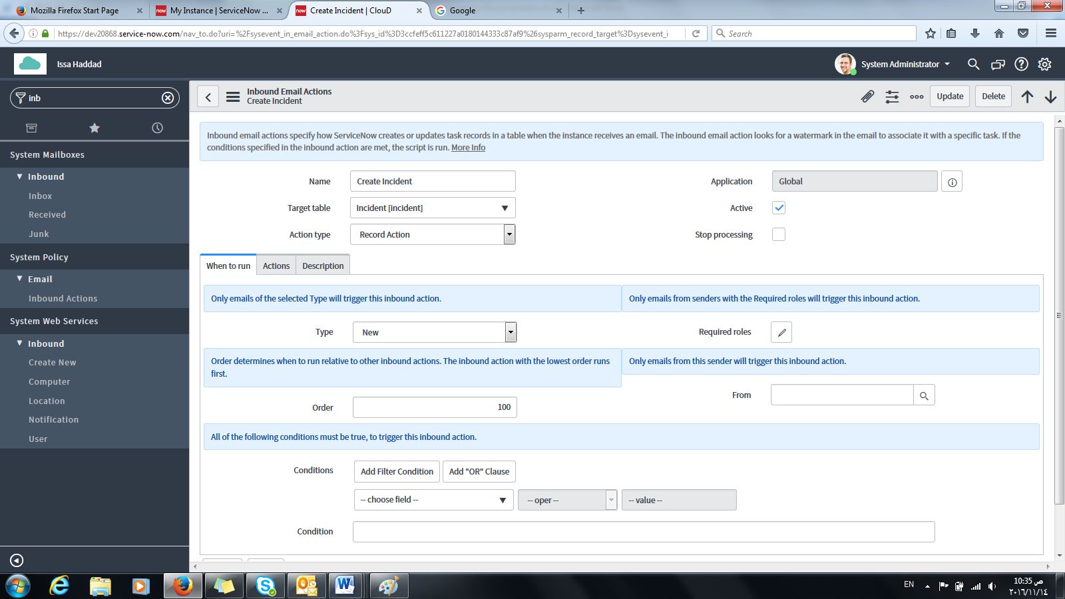

### Enable sending/receiving emails from system.

* System Diagnostics 🡪 Email Diagnostics.
* Enable sending/receiving emails.
* User should have notifications enabled in order to receive an email.

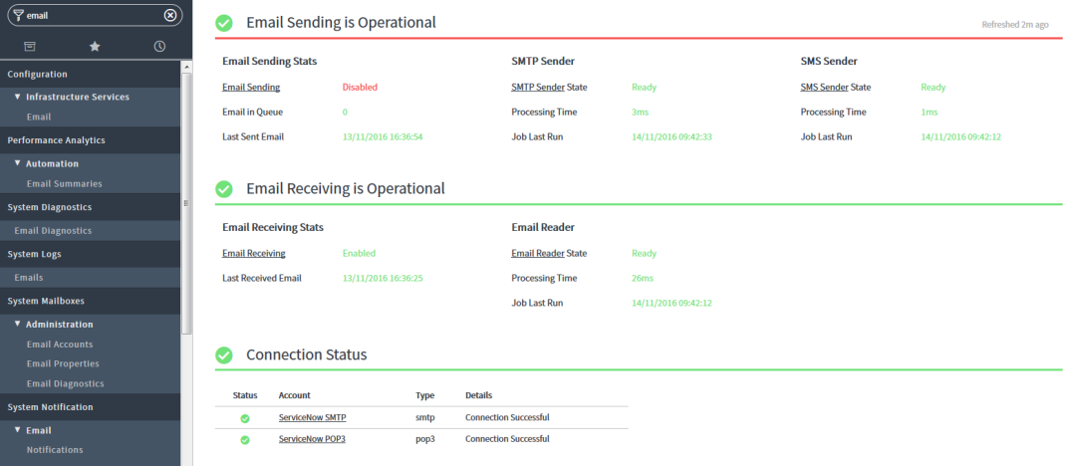

### 1.3 Get your instance’s email address

* Navigate to System Mailboxes 🡪 Administration 🡪 Email Accounts.
* Locate record name: Servicenow SMTP.
* Email will be in Username field.

### 1.4 Check received emails

* Navigate to System Mailboxes 🡪 Inbound 🡪 (Received) or (Inbox).
* Processed emails are found in received.
* Unprocessed emails are found in the inbox.

# Modifying form fields when conditions are met.

## Technical Solution

### Create new or modify business rules when conditions are met.

* Navigate to System Definitions 🡪 Business Rules.
* Click New.
* Insert Required Table to apply business rule on.
* Modify **When to run**, (**Actions**, and/or **Advanced tab**).

Note: Refer to table below. (To modify fields in the same form, you have to use the (Before) option.

|  |  |
| --- | --- |
| **Option** | **When the Rule Runs** |
| Before | *After* the user submits the form but *before* any action is taken on the record in the database. |
| After | *After* the user submits the form and *after* any action is taken on the record in the database. |
| Async | When the scheduler runs the scheduled job created from the business rule. The system [creates a scheduled job](http://wiki.servicenow.com/index.php?title=Creating_a_Scheduled_Job) from the business rule *after* the user submits the form and *after* any action is taken on the record in the database. |
| Display | *Before* the form is presented to the user, just *after* the data is read from the database. |

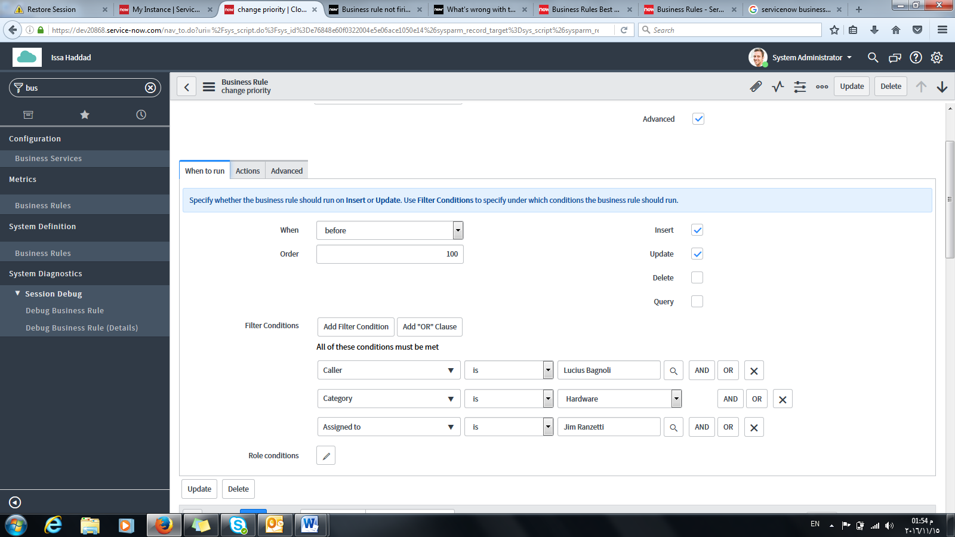

# Creating Knowledge Article form Incidents

## Technical Solution

### Open any desired not closed incident

* Navigate to Incident 🡪 All.
* Locate your desired incident.
* Check KB draft under Closure information tab.
* Set State to closed and insert Close notes.
* Insert Additional Comment under Notes Tab.

Note:

* Additional Comments = Text inside Knowledge Base Article.
* Short Description = Title of Knowledge Base Article.
* Do not add Knowledge Check Field from form Layout as it doesn’t work, instead use the available Draft KB/Knowledge field under Closure notes.

### Publish Article.

* Navigate to Knowledge 🡪 Articles 🡪 Unpublished.
* Locate and open your Article.
* Populate Knowledge Base field to desired value.

Note:

* Select IT inside Knowledge Base field so it can appear in Service Portal under KB categories.
* Populate Category field to desired value.
* Publish the article from within the form header.
* You should now be able to view your article under its corresponding category in Service Portal.

# Creating an inactivity monitor with email notification

## Technical Solution

[**https://community.servicenow.com/community/develop/blog/2015/01/08/get-active-with-inactivity-monitors**](https://community.servicenow.com/community/develop/blog/2015/01/08/get-active-with-inactivity-monitors)

### Setting up Inactivity Monitor

* Navigate to **System Policy > SLA > Inactivity Monitors**.
* Click **New**.
* Type a **Name**. For example, **Priority One Inactivity**.
* Select the task type to monitor in the **Table** field. For example, **Incident**.
* In **Wait**, specify the time in hours and/or minutes to wait before sending notification. For example, 2 hours.
* In **Condition**, at least one condition must be specified. You can set multiple conditions. For example, on a priority one incident inactivity monitor, the conditions could be:
* Click **Save.**  
  **Note:** The **Order** field on the Inactivity Monitor record is optional, but can be important. If more than one inactivity monitor could have their conditions met for a specific record, the monitor with the lowest **Order** number is used. As you create more inactivity monitors, double-check existing inactivity monitors and their conditions to identify the monitors that are related and could apply to the same record.

### Connecting a notification to the inactivity Monitor

* Now, you need to set up an event for the inactivity monitor. We want to create an email notification, so navigate to **System Policy > Email > Notifications**.
* Type a **Name**. For example, **Priority One Inactivity**.
* Select the correct **Table**. In this example we would use **Incident [incident]**.
* Under **Related Links**, click **Advanced view**.
* In **Type**, select **EMAIL**.
* In **Send when**, select **Event is fired.**
* In **Event name,** select **incident.inactivity**. If necessary, you can [create a new event](https://community.servicenow.com/external-link.jspa?url=http%3A%2F%2Fwiki.servicenow.com%2Findex.php%3Ftitle%3DEvents_and_Email_Notification%23Create_a_New_Event) and [register the event.](https://community.servicenow.com/external-link.jspa?url=http%3A%2F%2Fwiki.servicenow.com%2Findex.php%3Ftitle%3DEvent_Registry)
* Click **Update**.

# Closing an Incident Permanently

## Technical Solution

### Create an UI Policy to make state field read-only

* + 1. Navigate to System UI 🡪 UI Policy.
    2. Create a new UI Policy.
    3. Choose Incident table, write a short description and select the conditions to apply the UI policy action:
       - [state is closed]
       - [Closed on last week]
    4. Create a new UI Policy Actions.
    5. Set the state field to read-only.
    6. Save and update.

*Business rule can override the UI Policy but Emails cannot

# Modifying Reports Headers and Footers

## Technical Solution

### Modify Reports Headers and Footers

* 1. Navigate to Reports 🡪 Header Footer Templates
  2. Create new template or modify existing one

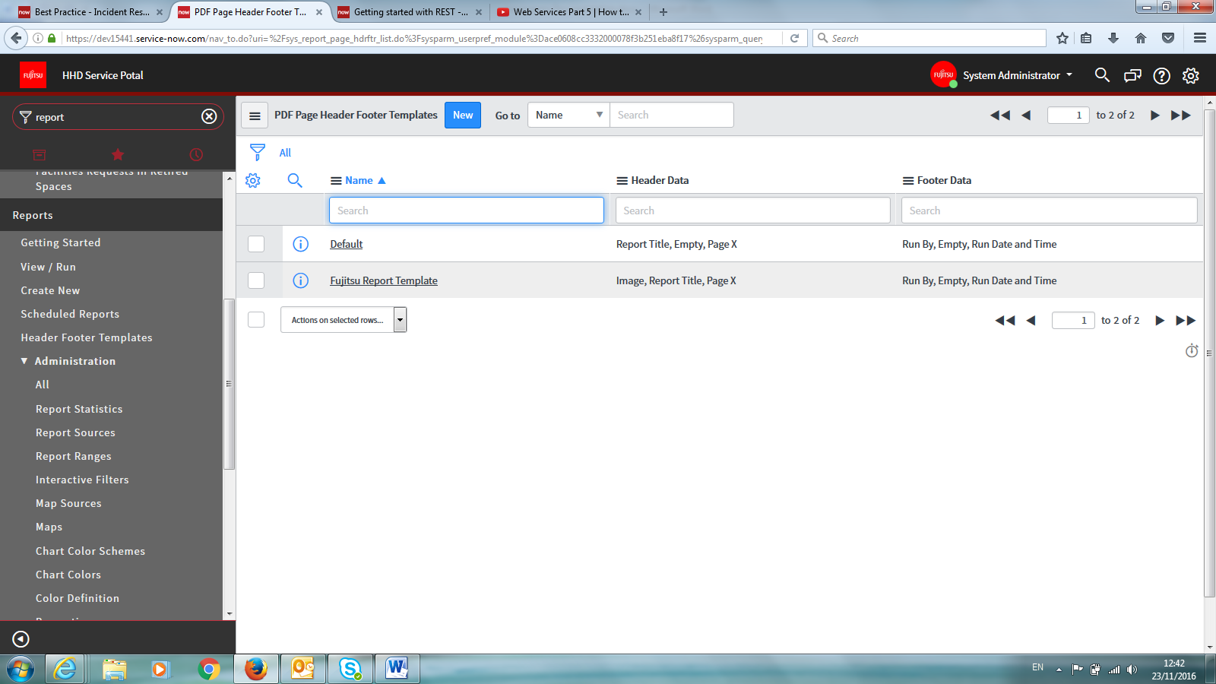

* 1. Specify properties needed

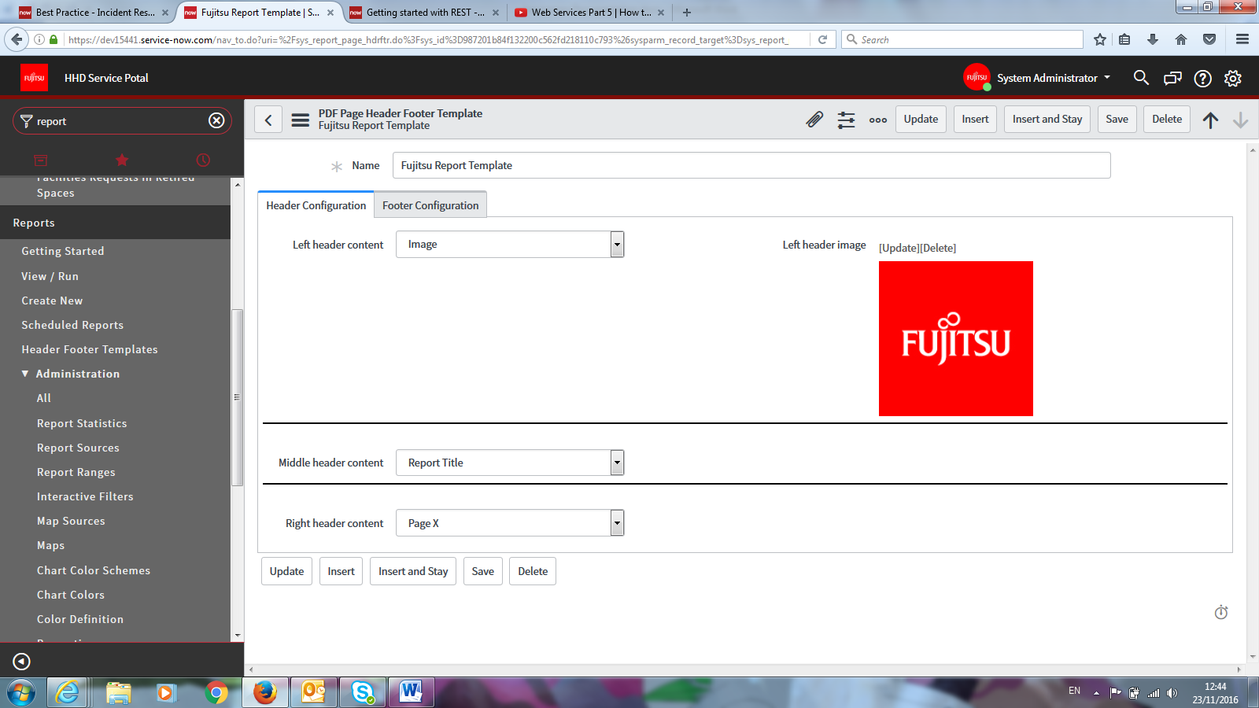

# Create link to reopen incident from Email

## Technical Solution

### Modifying required email template

* Navigate to System Policy 🡪 Email 🡪 template
* Locate “incident.ess.resolve”
* Modify and copy to new different template if necessary, if not then leave as is.

### Add email template to designated email notification

* Navigate to System Notification 🡪 Email 🡪 notification
* Locate “incident resolved” and open.
* Under “what it will contain”.
* Remove Message HTML content.
* Add “incident.ess.resolve” to Email template.

# Auto populating task in case form

## Technical Solution

### Create a new workflow

* Navigate to Service Level Management 🡪 Administration 🡪 workflow Editor.
* A new page will open in a new tab.
* On the right hand side, locate a plus sign button and click it.
* Name your workflow.
* Set Table as: “sn_customerservice_task.
* Enter required conditions on the table
* Click submit after filling required fields.

### Modify Workflow to add specific tasks.

* On the right hand side, under core tab, find Timers Activity 🡪 timer.
* Drag that activity between Begin and End in your workflow.
* When activity properties page appear. Fill in your activity name.
* Set “Timer based on” field to “A user specified Duration”
* Set “Duration” to 0 days, 0 hours, 0 mins, 1 second.
* Submit Activity.
* Drag and drop to workflow the activity “Create Task” under “Tasks” and place if after the timer activity.
* Enter Activity Name.
* Under Basics, set “Task Type” to “sn_customerservice_task”
* Populate other fields in the activity if required.
* Using the same steps as above, create as many tasks as required.
* Your final workflow should look at least like the figure shown below:

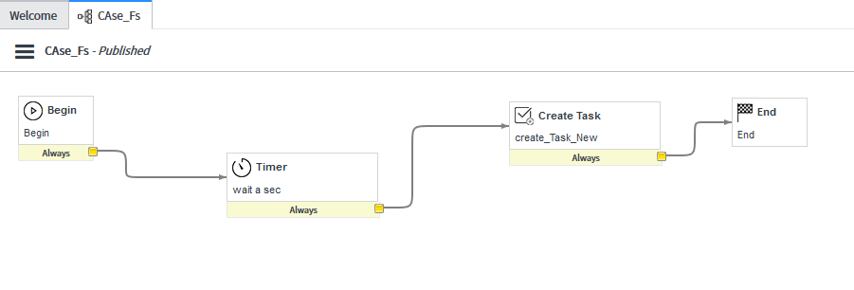

Note: if you would rather create a task without having to insert a timer activity beforehand, please follow the steps provided below.

* Navigate to Customer Service 🡪 cases 🡪 All.
* Open any case.
* Scroll down to Tasks tab, and create new task. This will open a different page.
* On that page, right click header 🡪 configure 🡪 business rules.
* Locate “update parent task for new case” and open.
* Enable page to be editable.
* Under Advanced Tab remove line code: “parentcase.update()” as shown below:

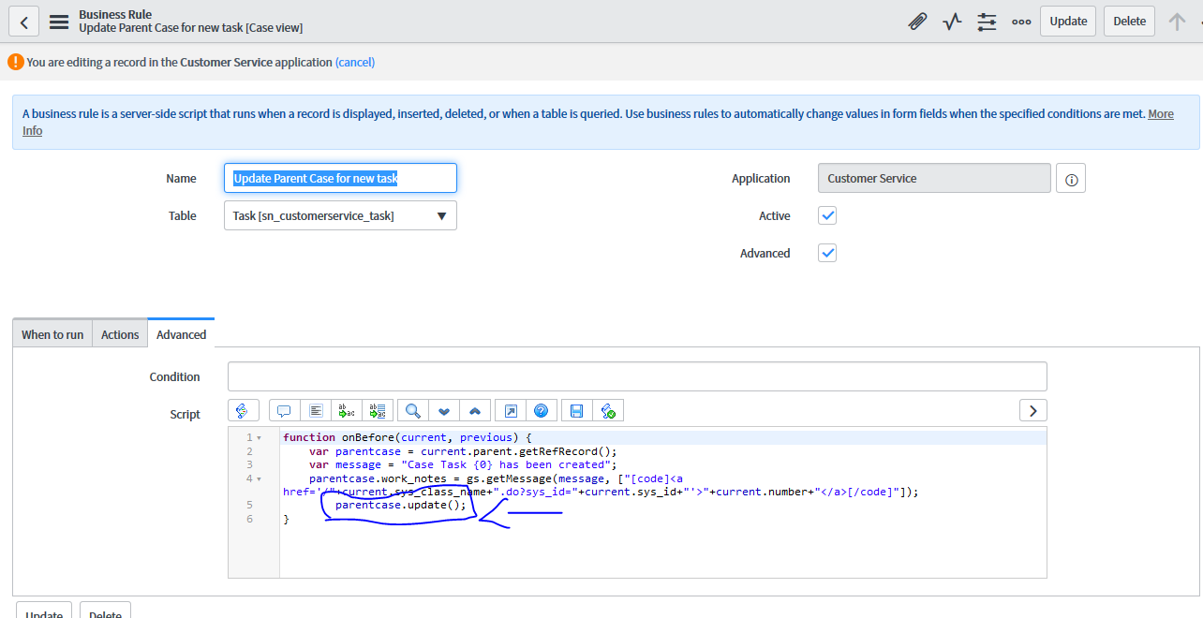

* This will remove the error you get when to timer activity exists that states:
  + Unique Key violation detected by database.
  + Invalid Insert.

# Creating catalog item in customer Service portal with execution plan

## Technical Solution

### Adding the widget on customer service portal

* Navigate to <https://dev20868.service-now.com/sp_config> after enabling the required plugin.
* Click on Designed button
* Locate and click csm_index.
* Drag and drop the widget “SC_categories” to the page.

### Customizing categories for Customer service portal

* Navigate to Catalog definition 🡪 Maintain Catalogs
* Click on Customer Service Catalog.
* Scroll down and under Categories 🡪 click new.
* Name you Category.

Note: Categories will not appear unless an item resides within them.

### Creating a Catalog item

* Navigate to Catalog Definitions 🡪 Maintain items.
* Click new to create a new item.
* Name item, add picture, description, price, etc if necessary.
* Make sure you enter your newly created category in the Category field.
* Click on submit.

### Creating new Execution plan for your item

* Navigate to Service Catalogs 🡪 Catalog policies 🡪 Execution plan
* Create new EP.
* Name your plan and populate Fields as necessary.

### Creating new Execution Plan Task

* In Filter Navigator: search for “sc_cat_item_delivery_task.list”
* Create new task.
* Enter name and populate fields as necessary.
* Follow same steps as above if you would like to create more than one task.

### Connecting new created tasks with the execution plan

* Navigate back to the your newly created Execution plan. Open it.
* Under Execution plan tasks tab. Click on edit.
* Add your newly created Task from the left column to the right column.
* Click on save.
* Click on update in your execution plan form.

### Connecting new created Execution plan with the Catalog item

* Navigate back to your newly created Catalog item. Open it.
* Enter your newly created execution plan to the designated Execution plan filed. Use lookup using list to easily find your execution plan.
* Click on update.

# Creating an Account when a customer registration request is approved

## Technical Solution

### Widget

### Create a widget that allows customers to register. Cloning customer registration request is preferable as they are very similar.

* Modify the code to match requirements.

HTML

<div class="panel b" ng-init="registrationInit()">

<!-- header -->

<div class="panel-heading bg-primary">

<h4 class="panel-title">${Account Registration}</h4>

</div>

<!-- body -->

<div class="panel-body" >

<form ng-submit="$event.preventDefault()" class="form-horizontal">

<!--

<div ng-if="data.sys_id != '-1' && data.status == 'success'" class="alert alert-success" role="alert">{{data.message}}</div>

<div>

<sp-model form_model="data.f" mandatory="mandatory"></sp-model>

</div>

-->

<!-- First Name input-->

<div class="form-group">

<label class="col-sm-3 control-label">${First Name}</label>

<div class="col-sm-6">

<input ng-model="c.first_name" name="first_name" placeholder="${first name}" class="form-control">

</div>

</div>

<!-- Last Name input-->

<div class="form-group">

<label class="col-sm-3 control-label">${Last Name}</label>

<div class="col-sm-6">

<input ng-model="c.last_name" name="last_name" placeholder="${last name}" class="form-control">

</div>

</div>

<!-- Business Email input-->

<div class="form-group">

<label class="col-sm-3 control-label">${Business Email}</label>

<div class="col-sm-6">

<input ng-model="c.email" name="email" placeholder="${business email}" class="form-control">

</div>

</div>

<!-- Registration Code input-->

<!--

<div class="form-group">

<label class="col-sm-3 control-label">${Registration Code}</label>

<div class="col-sm-6">

<input ng-model="c.code" name="code" placeholder="${You company registration code}" class="form-control">

</div>

</div>

-->

<!-- Privacy Policy & Terms conditions -->

<div class="form-group col-sm-12 input-group-checkbox">

<div class="col-sm-12">

<label class="col-sm-3 control-label"></label>

<input ng-model="c.policy" id="checkbox_agree" type="checkbox" name="policy">

I agree to the <a href="/sn_customerservice_registration_privacy_policy_doc.do" target="_blank">&nbsp;Privacy Policy&nbsp;</a>

and Community

<a href="/sn_customerservice_registration_terms_doc.do" target="_blank">&nbsp;Terms and Conditions</a>

</input>

</div>

</div>

<script src="https://www.google.com/recaptcha/api.js?onload=onloadCallback&render=explicit" async defer> </script>

<script>

var onloadCallback = function() {

var captchaVerified;

var captchaWidget;

var verifyCallback = function(grc) {

if ((grc == "") || (grc == undefined))

captchaVerified = false;

else

captchaVerified = true;

jQuery("#captchaVerified").attr("value",captchaVerified);

CustomEvent.fireAll('sn_csm_captcha_verified',captchaVerified);

};

captchaWidget = grecaptcha.render('html_element', {

'sitekey' : "6LeiwAYTAAAAAAscPMJuMno9Tbwt3KXqSEPmQhu2",

'callback' : verifyCallback,

'theme' : 'light',

'expired-callback' : captchaExpired

});

};

var captchaExpired = function(){

captchaVerified = false;

jQuery("#captchaVerified").attr("value",captchaVerified);

CustomEvent.fireAll('sn_csm_captcha_verified',captchaVerified);

};

</script>

<!-- Google Recaptcha -->

<div id="captcha_form_group" class="form-group">

<input ng-model="c.captchaVerified" type="checkbox" name="captchaVerified" id="captchaVerified" style="display:none;" class="form-control">

<label class="col-sm-3 control-label">${Security Code}</label>

<span class="col-sm-9">

<form action="?" method="POST">

<div class="g-recaptcha" id="html_element"></div>

<span class="help-block" id="retype_captcha"></span>

</form>

</span>

</div>

<div>

<button type="submit"

ng-disabled="data.status == 'success' || c.showSubmit()"

ng-click="c.action()"

class="btn btn-primary">${Submit}</button>

</div>

</form>

</div>

<!-- footer

<div class="panel-footer" ng-if = "data.sys_id == '-1'">

<button ty

pe="submit" ng-disabled="mandatory.length != 0" ng-click="c.action()" class="btn btn-primary">${Save} <span ng-if="saveButtonSuffix">(${{{saveButtonSuffix}}})</span></button>

<span>{{status}}</span>

<div ng-if="mandatory.length" class="alert alert-info" style="margin-top: .5em">

<span ng-if="mandatory.length > 0">${Required information} </span>

<span ng-repeat="f in mandatory" class="label label-danger" style="margin-right: .5em; display: inline-block;">{{f.label}}</span>

</div>

-->

</div>

Client-side

function ($scope, $rootScope, $timeout, spUtil, $location) {

var c = this;

c.captchaVerified = false;

c.policy = false;

CustomEvent.observe('sn_csm_captcha_verified', function(captcha_value) {

c.captchaVerified = captcha_value;

scope.$apply();

});

c.showSubmit = function(){

return !( c.first_name && c.policy == true && c.captchaVerified == true && c.last_name && c.email);

};

c.action = function() {

c.data.action = 'register';

c.data.first_name = c.first_name;

c.data.last_name = c.last_name;

c.data.email = c.email;

//c.data.code = c.code;

c.server.update().then(function(response) {

var data = response["result"];

if (response.status == 'success') {

c.success = response["message"];

window.location.reload();

} else if (response.status == 'error') {

c.message = 'There was an error processing your request';

}

});

};

$scope.registrationInit = function () {

};

}

**Server-side**

(function($sp, input, data, options) {

"use strict";

data.is_logged_in = gs.getSession().isLoggedIn();

data.sys_id = '-1';

data.captch_url= 'https://www.google.com/recaptcha/api.js?onload=onloadCallback&render=explicit&hl=' + gs.getSession().getLanguage() ;

if (input && input.action == 'register' && input.first_name && input.last_name && input.email ) {

var result = {};

var gr = new GlideRecord('sn_customerservice_registration');

gr.initialize();

gr.setValue('first_name', input.first_name);

gr.setValue('last_name', input.last_name);

gr.setValue('email', input.email);

gr.setValue('account',input.first_name+ ' '+ input.last_name);

//gr.setValue('registration_code', input.code);

var sys_id = gr.insert();

if (!gs.nil(sys_id)) {

data.sys_id = sys_id;

data.status = "success";

data.message = gs.getMessage("Your request has been submitted and is pending review. You will receive an email when your request is processed.");

} else {

data.status = "error";

}

data.result = result;

return data;

}

})($sp, input, data, options);

### Deactivate verification code-related business rules and client scripts

* [Registration code read only](https://dev15441.service-now.com/sys_script_client.do?sys_id=72d26c56c31112004bd67bfaa2d3ae2d&sysparm_record_target=sys_script_client&sysparm_record_row=5&sysparm_record_rows=6&sysparm_record_list=sys_class_name%3Dsys_script_client%5Eactive%21%3Dtrue%5EtableSTARTSWITHsn_customer%5EORDERBYname)
* [Update account based on reg code](https://dev15441.service-now.com/sys_script.do?sys_id=36e01fd3c35302003a657bfaa2d3ae92&sysparm_view=case&sysparm_record_target=sys_script&sysparm_record_row=1&sysparm_record_rows=1&sysparm_record_list=collectionCONTAINSsn_cust%5Eactive%21%3Dtrue%5EORDERBYzztextsearchyy)

### Create a new business rule to create a new account with each new contact

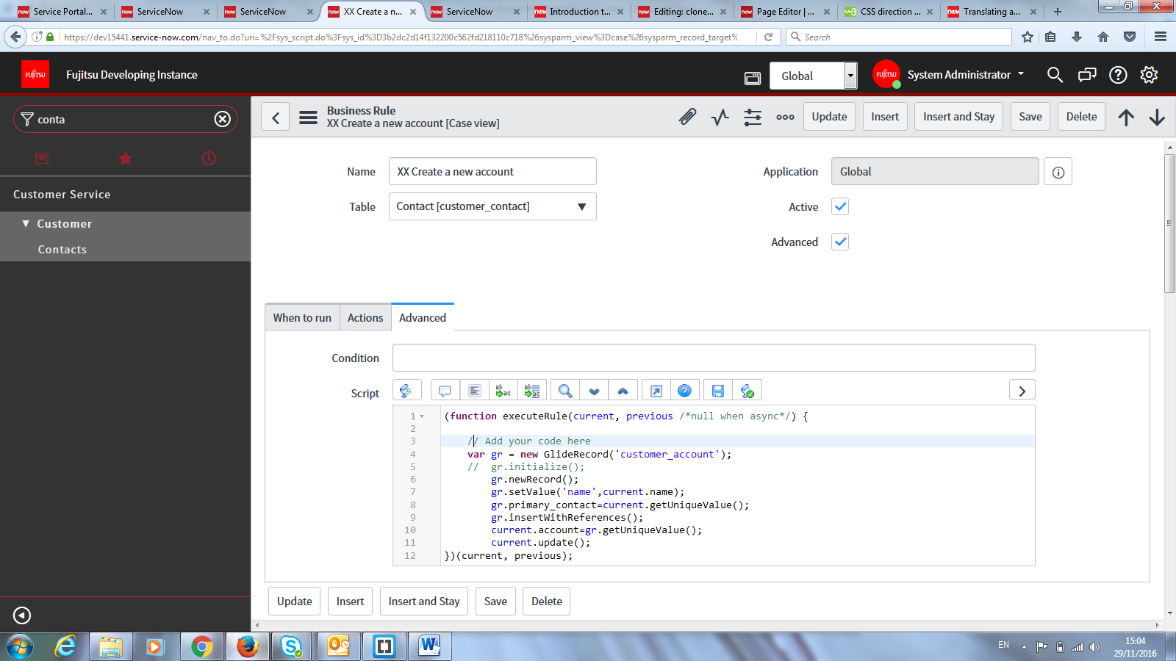

(function executeRule(current, previous /*null when async*/) {

// Add your code here

var gr = new GlideRecord('customer_account');

// gr.initialize();

gr.newRecord();

gr.setValue('name',current.name);

gr.primary_contact=current.getUniqueValue();

gr.insertWithReferences();

current.account=gr.getUniqueValue();

current.update();

})(current, previous);

# Asset management notes

## Technical Solution

### Use The Asset Management Overview module.

* Role required: asset, sam, or admin
* Create reports on various asset tables
* Navigate to Asset 🡪 Overview

### View assets that are in stock.

* Role required: asset or inventory_admin
* Inventory 🡪 Stock 🡪 In Stock

### Create an Asset class.

* + The default asset classes are Hardware, Software License, and Consumable.
  + Role required: asset or category_manager
  + Navigate to System Definition 🡪 Tables & Columns.
  + Create New Table. Name: Vehicle, Extend table: Asset, Module: Asset.
  + Create new model category + model.

### Create hardware, software license, consumable, license, and facility assets.

* + Role required: asset
  + Navigate to Asset 🡪 Portfolio 🡪 All Assets
  + Click New
  + Depreciation 🡪 hardware asset.
  + Enter Values
  + Right Click header 🡪 Save
  + Calculate Depreciation.

### Pre-allocated assets.

* + A pre-allocated asset physically exists, but is not yet a financial liability.
  + Vendor still owns but its available in your stockroom
  + Role required: asset.
  + Model category table: cmdb_model_category
  + Navigate to Asset 🡪 Portfolio and select All Assets, Hardware Assets, or Other Assets.
  + Click New.
  + Select a Model Category. (Must have the Allow pre-allocated option selected.)
  + Select a Model.
  + Select state as “in stock” or “in transit” 🡪 sub-state: “pre-allocated”
  + Select quantity, and maybe “stockroom”. Click save 🡪 then pre-allocate asset button

### Split pre-allocated assets.

* + Choose an asset that is pre-allocated.
  + Click reference in table list
  + Click split
  + Enter quantity.

### Fixed asset.

* Fixed assets are containers that can hold multiple assets.
* Role required: “financial_mgmt_admin” & “financial_mgmt_user”.
* Financial management application is called now “cost”
* Navigate to cost 🡪 fixed asset.
* Click New.
* Enter a name. Submit.

### Add assets to fixed asset.

* + Navigate to a fixed asset.
  + In covered assets 🡪 click edit.
  + Add your assets.

### Sum the residual value of fixed asset.

* + Navigate to a fixed asset.
  + Click sum residual value.

### Use depreciation.

* + Two type: Declining Balance or Straight Line
  + Role required: financial_mgmt_admin or financial_mgmt
  + Navigate to cost 🡪 depreciation
  + Click category
  + Click New and enter a name.
  + Select a category
  + Add script to calculate depreciation
  + Click on submit.

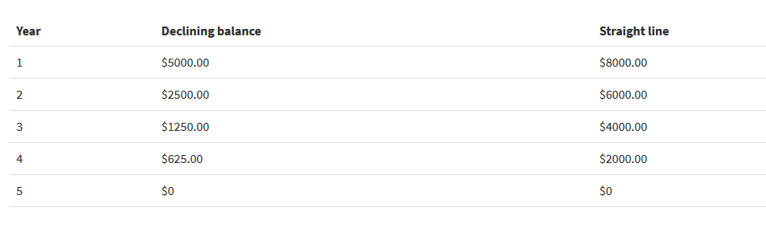

### Create license asset.

* + Role required: sam.
  + Like specifying how many computers are you allowed to install on a particular software.
  + Navigate to asset 🡪 portfolio 🡪 license asset.
  + Click new.
  + In rights field, enter the number of entitlements.

### States and sub-states.

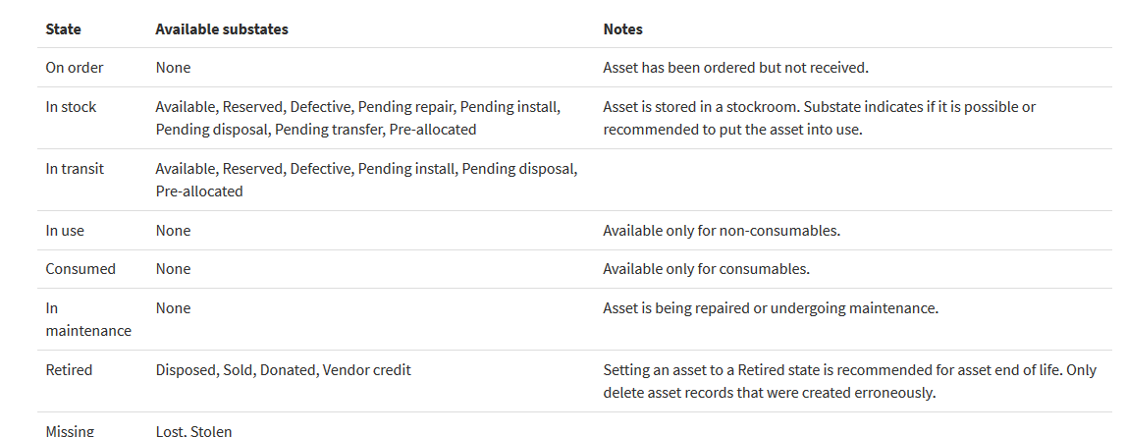

### Asset-CI relationship.

* A CI is automatically created as soon as the asset model is created inside a new asset.

### Asset-CI mapping.

* + Asset to CI: Changes to the asset are updated to the logically mapped CI.
  + CI to asset: Changes to the CI are updated to the logically mapped asset.
  + Both: Changes to either the asset or the CI are updated to the logically mapped record.

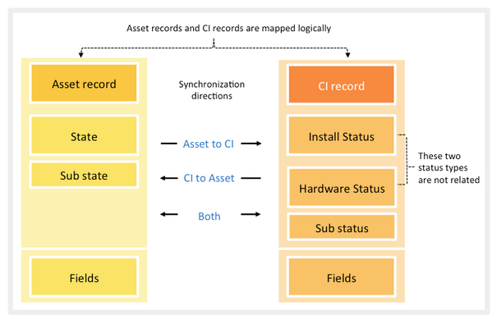

### Create your own mapping.

* + Role requires: asset or admin.
  + Navigate to asset 🡪 administration 🡪 asset-CI field mapping.
  + Click new.
  + Select asset and CI fields.
  + You can add conditions under the advanced view.
  + Select active and submit.

### Map asset state and CI install status.

* Role required: asset or admin
* Navigate to asset 🡪 administration 🡪 map asset state and CI install status.
* Sync direction: set direction of mapping you require

### Map asset state and CI install status.

* Role required: asset or admin
* Navigate to asset 🡪 administration 🡪 map asset state and CI hardware status.
* Sync direction: set direction of mapping you require

### Consumable asset.

* Tracked by group (model) not individually
  + Same location
  + Same state
  + Consumed by same asset
* Stages
  + In order, In stock, Intransit, consumed
  + In maintenance, retired, missing

### View consumable assets.

* + Role required: model_manager
  + Navigate to product catalog 🡪 product model 🡪 consumable model.

### Create consumable asset.

* + Role required: asset
  + Navigate to asset 🡪 portfolio 🡪 consumable
  + Click new.
  + Set class to consumable is automatic.

### Consume a consumable asset.

* + Navigate to asset 🡪 portfolio 🡪 consumable.
  + Choose state “in stock” and sub-state “available”.
  + Click on consume.
  + Enter quantity, asset, and user which consumed.
  + Click on ok.

### Retire an asset.

* Changing this state changes the status of the configuration item.
* Navigate to asset 🡪 portfolio 🡪 all assets.
* Change state to retired.
  + Sub-state to disposed, sold, donated, vendor credit.
* Update

### Delete an asset.

* + Navigate to asset 🡪 portfolio 🡪 all assets.
  + Select checkbox next to asset
  + In action select delete.

### Transfer Order.

* + Moving assets between company stockrooms.
  + Consumable 🡪 quantity >=1
  + Non-consumable 🡪 quantity =1

### Creating a transfer order.

* Navigate to inventory 🡪 transfer order 🡪 create transfer order.
* Enter from.to stockroom
* Enter date. Update
* Select transfer order.
* Click new in transfer order line.
* Select a model. If consumable select quantity. submit
* You can add more transfer lines
* Click ready for fulfillment.
* Click prepare for shipment. *** can be made on individual transfer lines
* Click ship. *** can be made on individual transfer lines
* Select each individual line 🡪 click on received
* After all lines are received 🡪 transfer order is set to “received”.

### Process of transfer Order (stage).

* + Draft 🡪 order can be deleted.
  + Requested 🡪 after ready for fulfillment.
  + Shipment preparation 🡪 after prepare for shipment. Or as soon as 1 transfer-line is set to prepare for shipment.
  + Cancelled (closed complete) 🡪 You can cancel transfer line after shipment preparation
  + In transit 🡪 after you ship (shipment preparation)
  + Partially shipped 🡪 if not all lines are shipped.
  + Fully shipped 🡪 if all lines are shipped.
  + Received 🡪 if all lines are received.
  + Delivered 🡪 only used with work management, if item delivered to work agent.

### Asset in transfer order.

* + Sub-state changes on form.
  + “Active to” is automatically selected. Asset cannot be involved in another transfer order
  + Asset state 🡪 “in stock pending transfer”
  + Asset state 🡪 “in transit > reserved” if order in transit.
  + Asser state 🡪 “in stock > available” if order received.

### Delete order or line in draft stage only.

* + Select checkbox next to record on the table
  + Action 🡪 delete

### Return items received.

* + If defected, etc...
  + Navigate to inventory 🡪 transfer order 🡪 transfer order returns. To check received.
  + Navigate to inventory 🡪 transfer order 🡪 Transfer order.
  + Select received order
  + Open order line
  + Click return, enter quantity, reason.
  + Check box if defective.
  + Click ok, and update.
  + New transfer order line is created to send back defective item.
  + New transfer order must move through regular process.

### Create a stockroom.

* + Navigate to inventory 🡪 stock 🡪 stockrooms
  + Click new.
  + Enter location and other fields.
  + If not external (managed by third party) it is internal.
  + Click on submit.

### Delete a stockroom.

* Role required: inventory_admin.
* If no assets in stockroom, check box next to record 🡪 delete action
* If assets in stockroom
  + Navigate to asset 🡪 portfolio 🡪 all assets
  + Personalize list to add stockroom column
  + Show all assets in the stockroom you want to delete.
  + Change stockrooms of all these assets.
  + Then go and delete stockroom by checking box and choosing action “delete”

### Create stockroom type.

* + Navigate to inventory 🡪 stock 🡪 stockroom
  + **Priority:** indicates the order of stockrooms the parts should be sourced from. For example, if a personal stockroom (priority 2) contains the required part, the personal stockroom receives priority over the Central Stockroom (priority 7) because the part in the personal stockroom does not require delivery.
  + **Shipment Required:** informs the system if a transfer order needs to be created when the part is sourced from a stockroom of the given type. For example, a part in a personal stockroom does not require shipment, so no transfer order is needed.

### Stock rules.

* Navigate to inventory 🡪 stock 🡪 stock rules.
* Stock rules are defined criteria stating that when inventory of a particular asset in a particular stockroom reaches a specified threshold, a certain number should either be transferred from another stockroom or ordered from a vendor.
* options
  + An email can be sent to the stockroom manager to place vendor order.
  + Transfer order is generated automatically.
    - This considers existing transfer orders and does not generate new if one already exists.
* Scheduled job “stock rule runner” runs once per day and compares threshold.
* How are jobs being handled, like sending email? Is it automatic to manager?

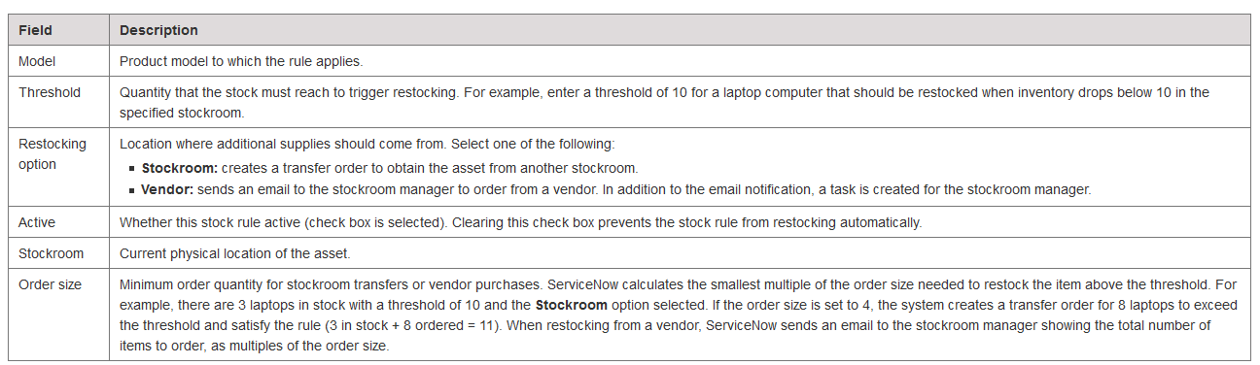

### Create new vendor/manufacturer.

* + Role required: user_admin.
  + Navigate to organization 🡪 vendors, manufacturers, or companies.
  + Switch to default view. Don’t know what the difference between default and vendor view?
  + Click new, select either manufacturer or vendor.
  + Enter information, then click submit.

### Location module.

* + Table name: Cmn_location.
  + Navigate to cost 🡪 location.
  + Click New
  + Add location to a stockroom by adding a longitude and latitude.
  + Enter other required information
  + Click submit.

# Creating Calendar in Homepage to show Changes

## Technical Solution

### Creating the report Calendar.

* Navigate to Reports 🡪 Create New
* Give an appropriate name to the report.
* In field “Table”, enter change_request table.
* In field “Calendar By”, enter planned start date.

### Customizing the report Calendar.

* Navigate to the “change_request” table.
* Open any form in the table.
* Right click header, configure dictionary.
* Select first record that has no value in column_name field.
* Click on the advanced view.
* In the Attributes field: enter the sentence below in the end of what already available.
  + “,calendar_element=number;short_description;risk”
  + Note: if field is empty, remove the preceding comma.
  + Comma: separates elements
  + Semicolon: separates attributes

# Creating Custom Applications

## Technical Solution

### Table creation.

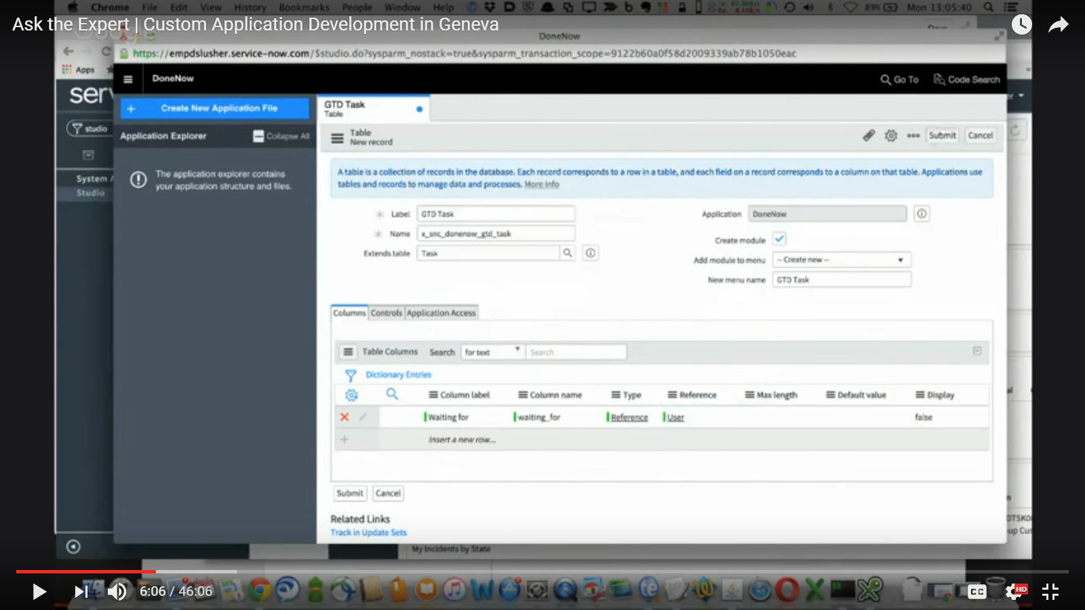

### Forms

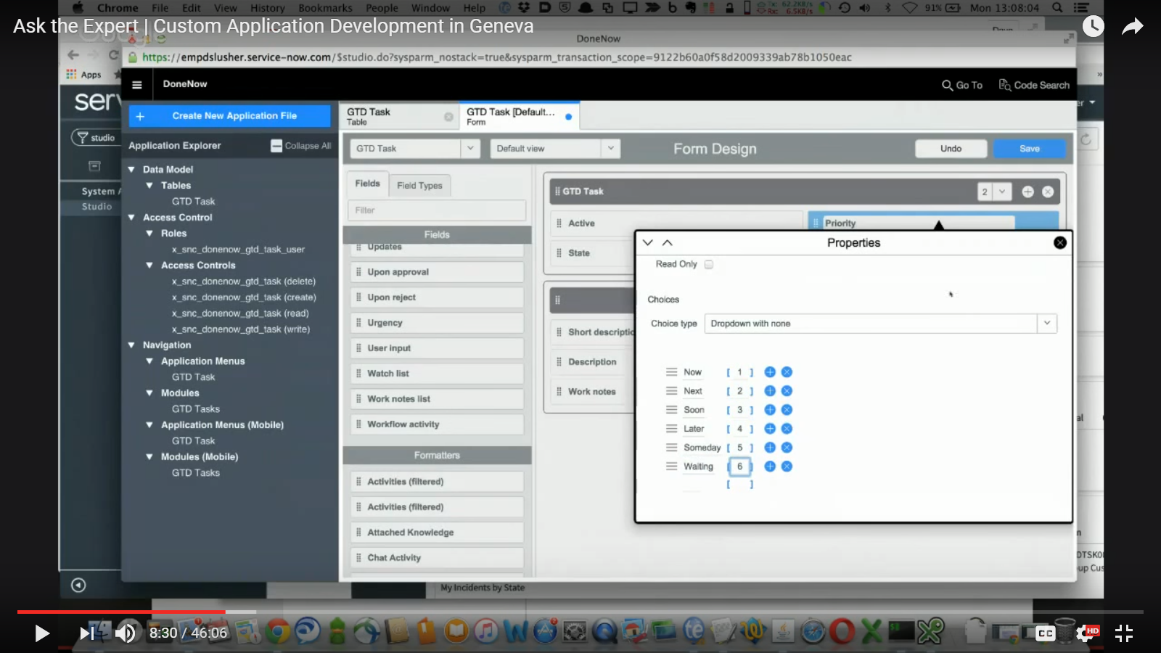

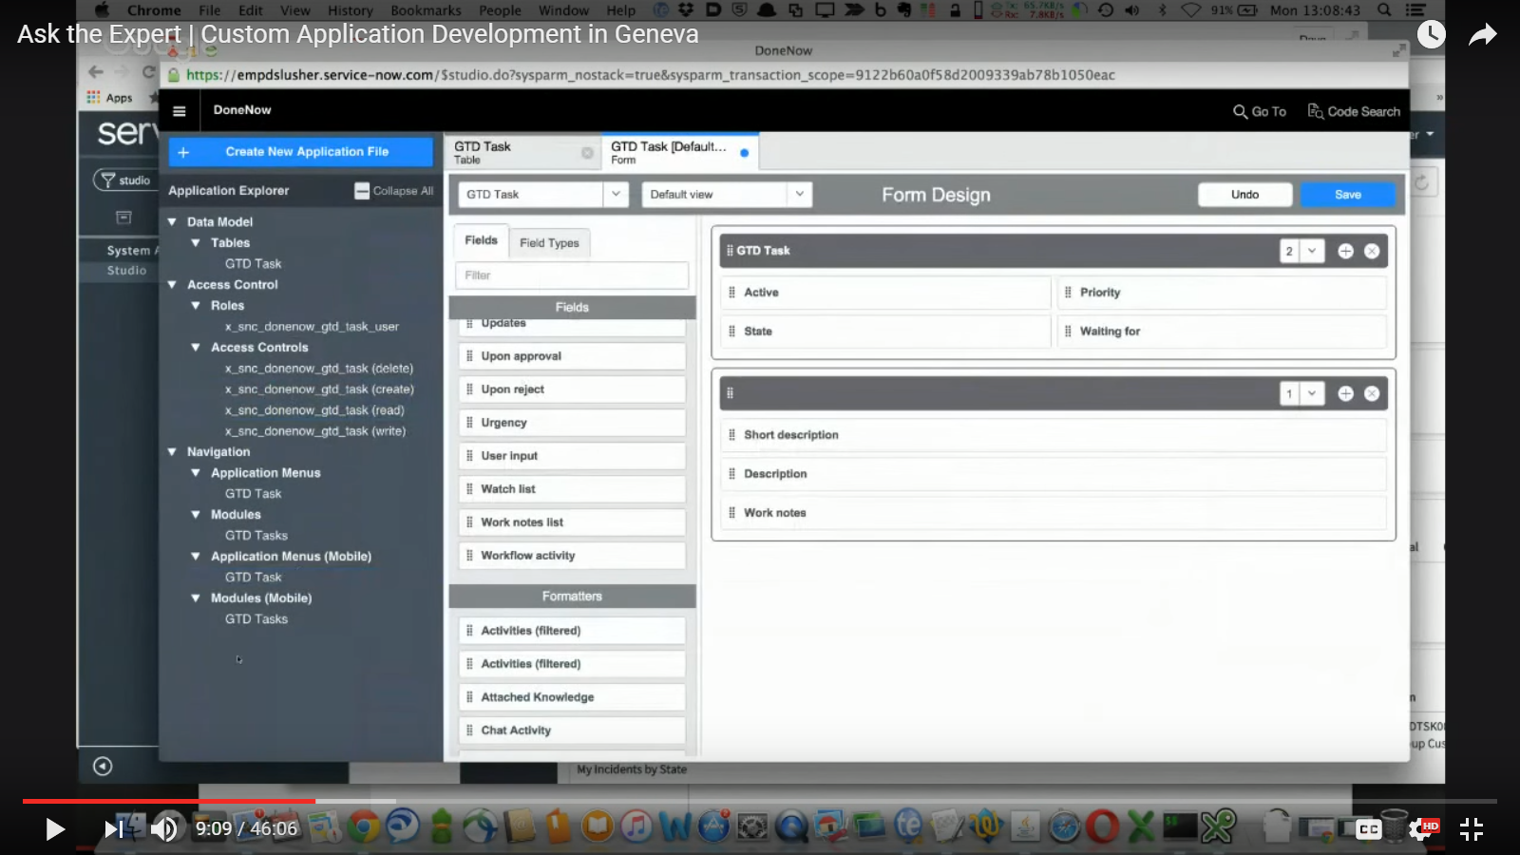

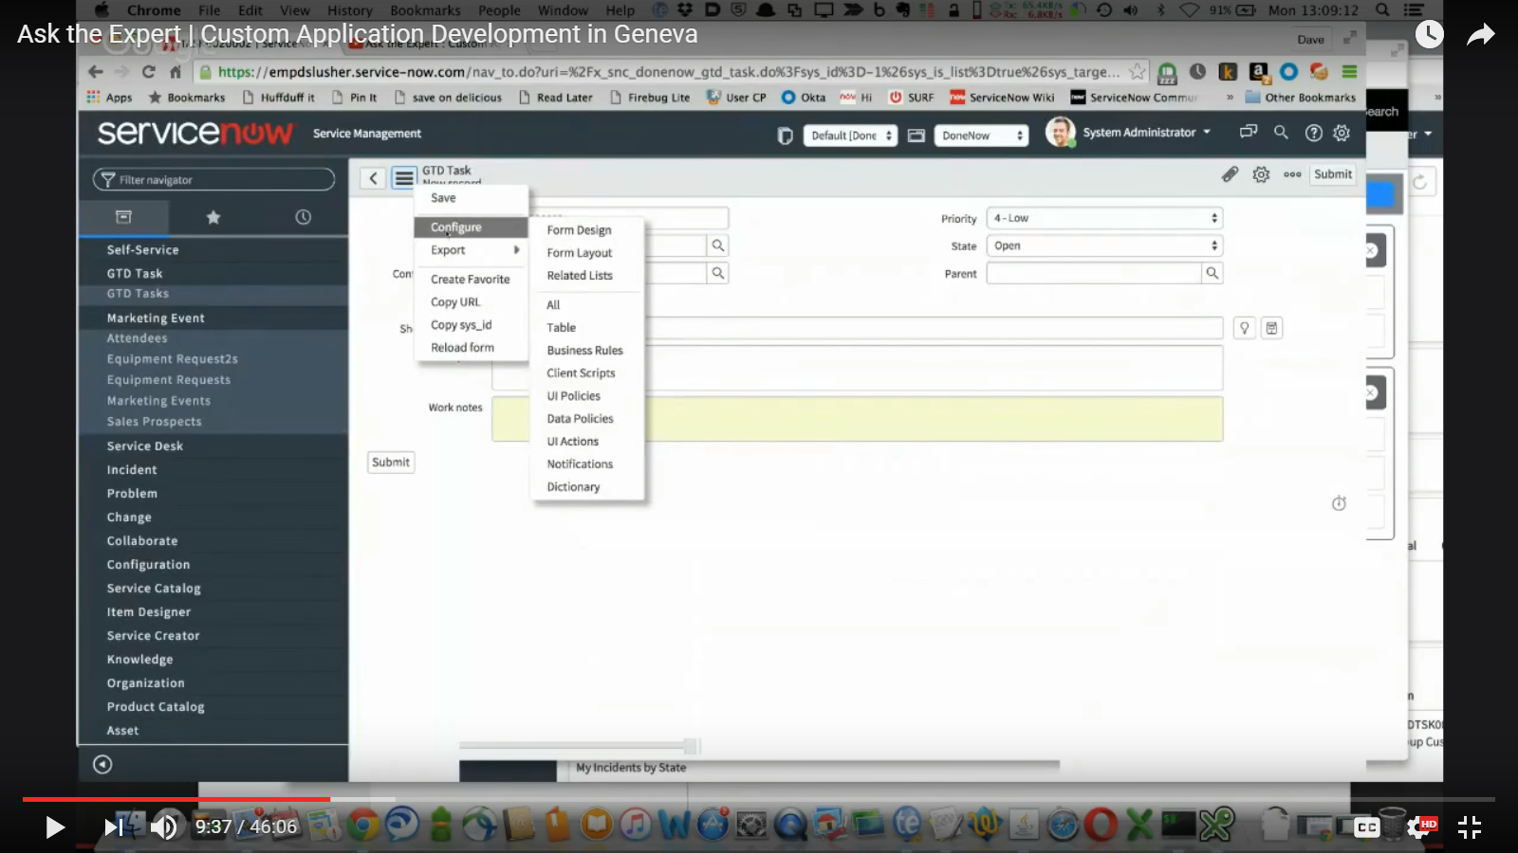

### UI policy.

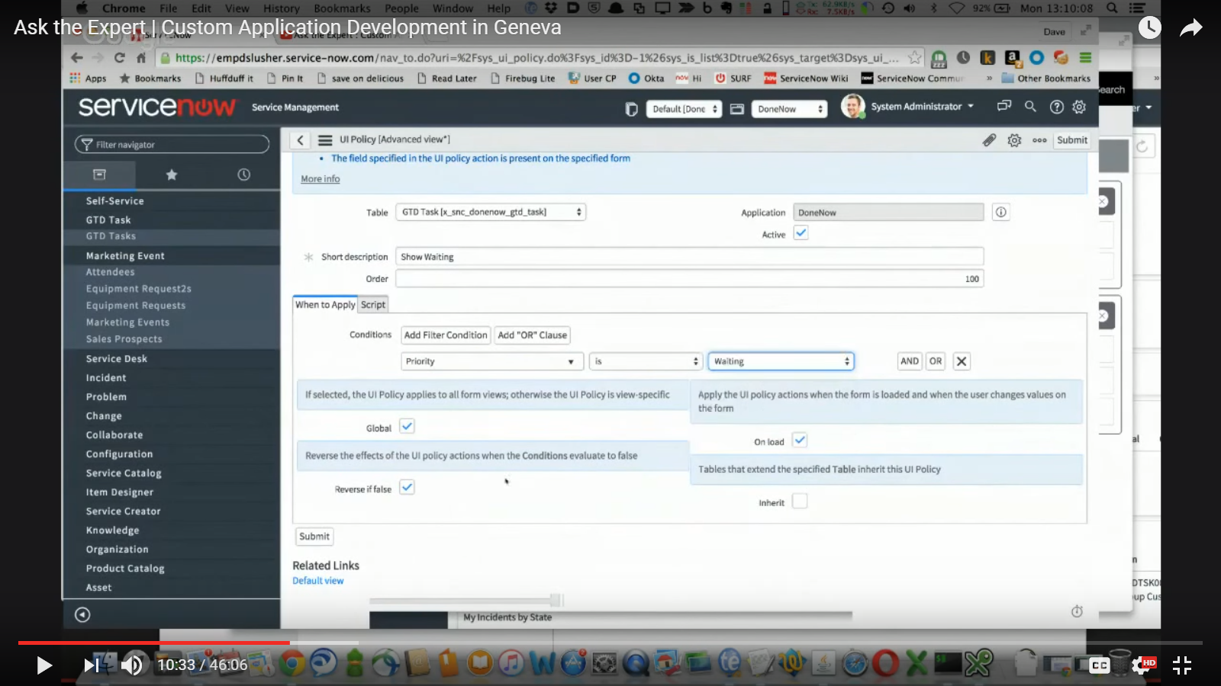

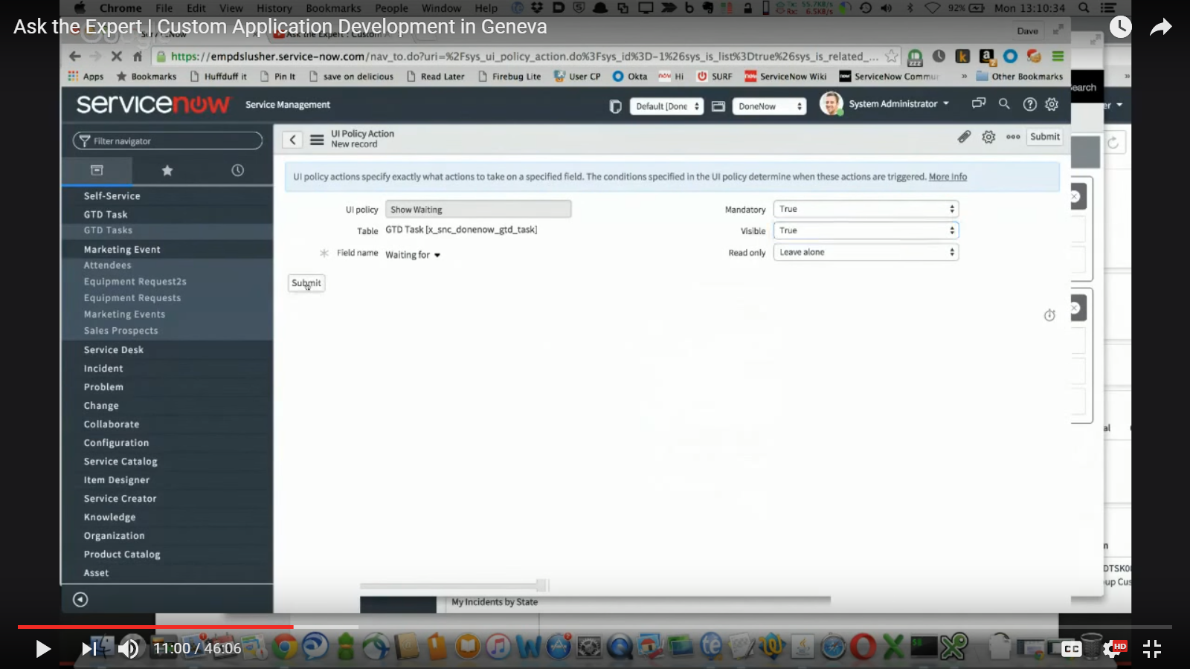

### Module form Studio.

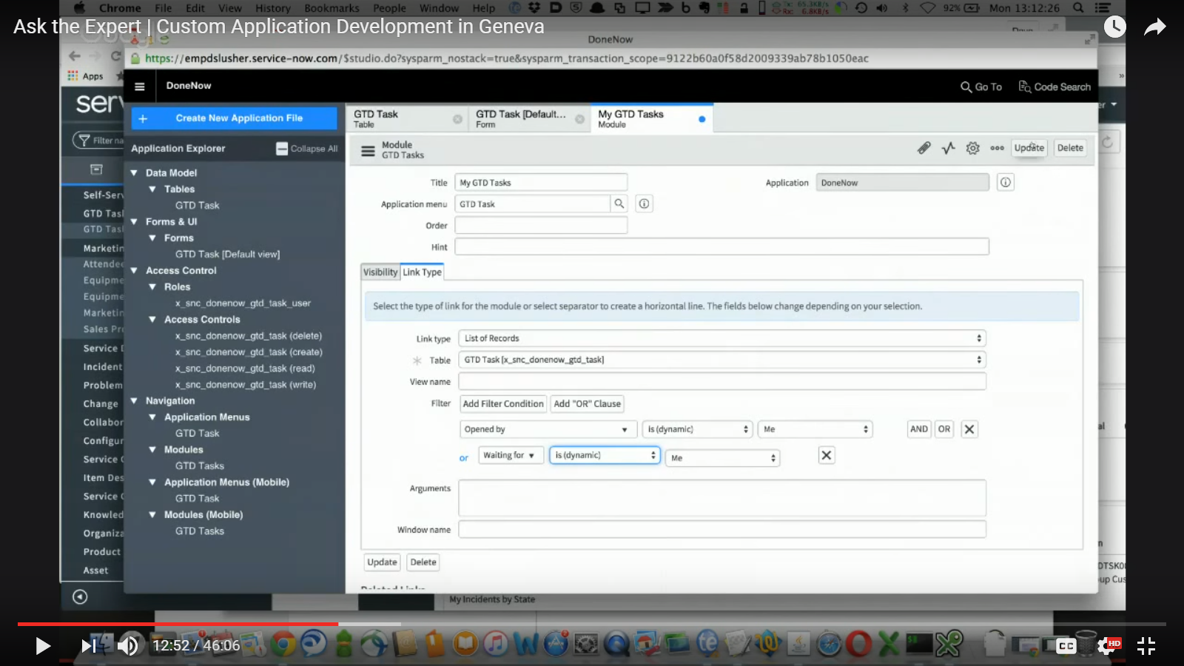

### Inbound Email Action.

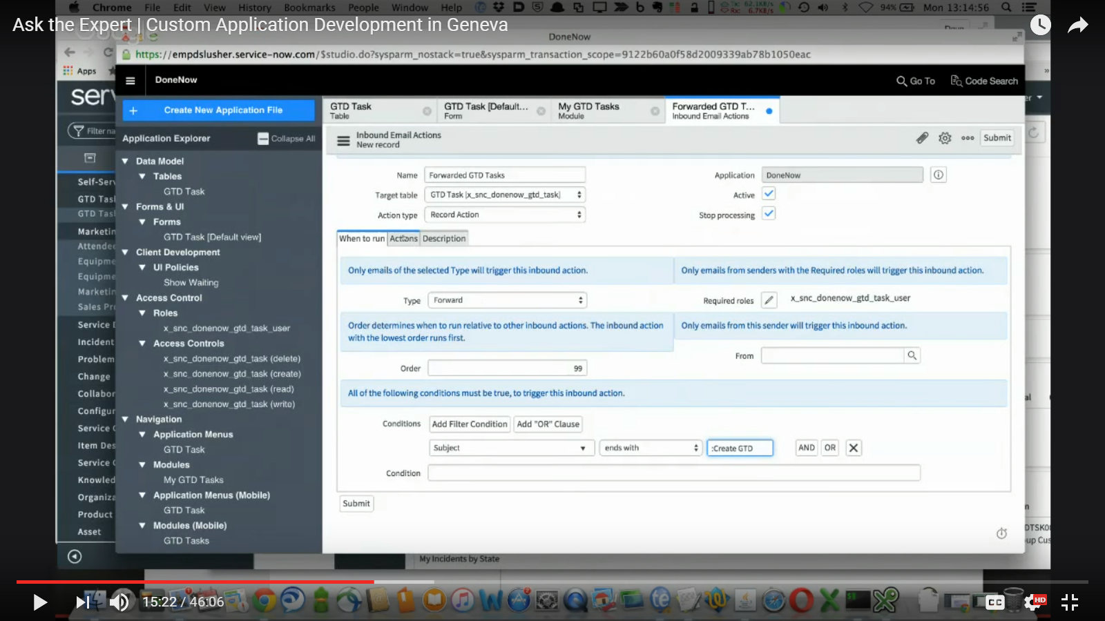

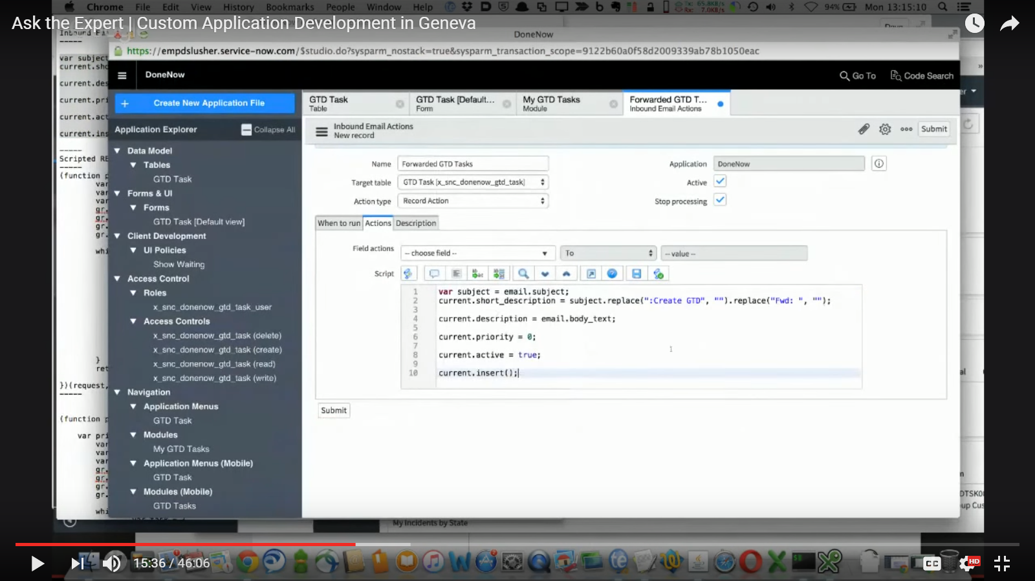

### Scripted REST API + resources.

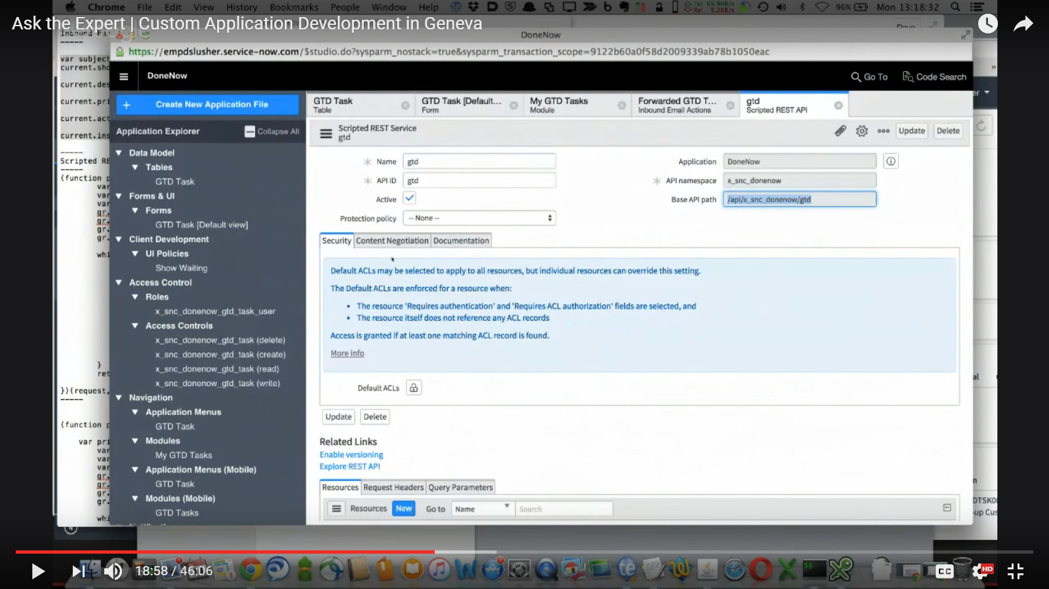

Resource:

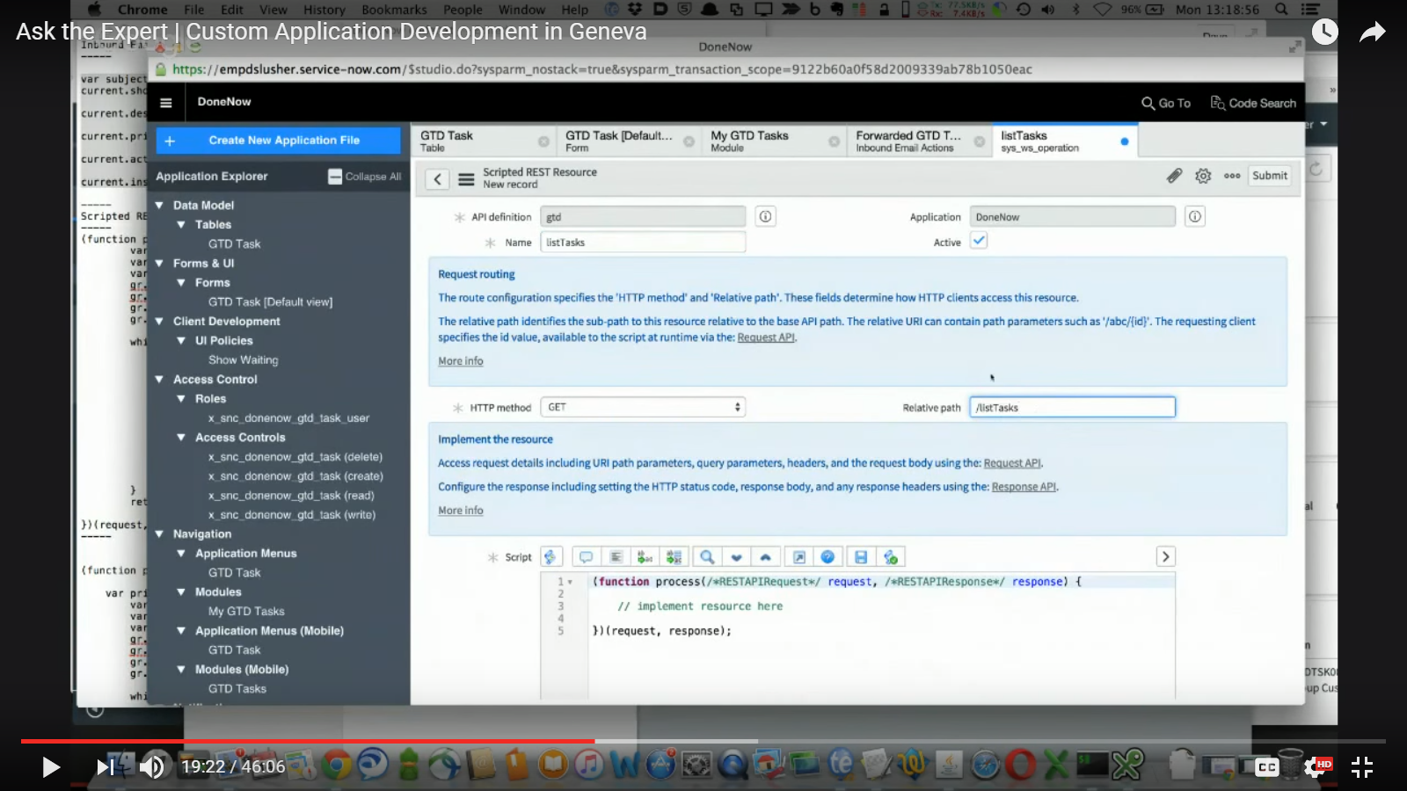

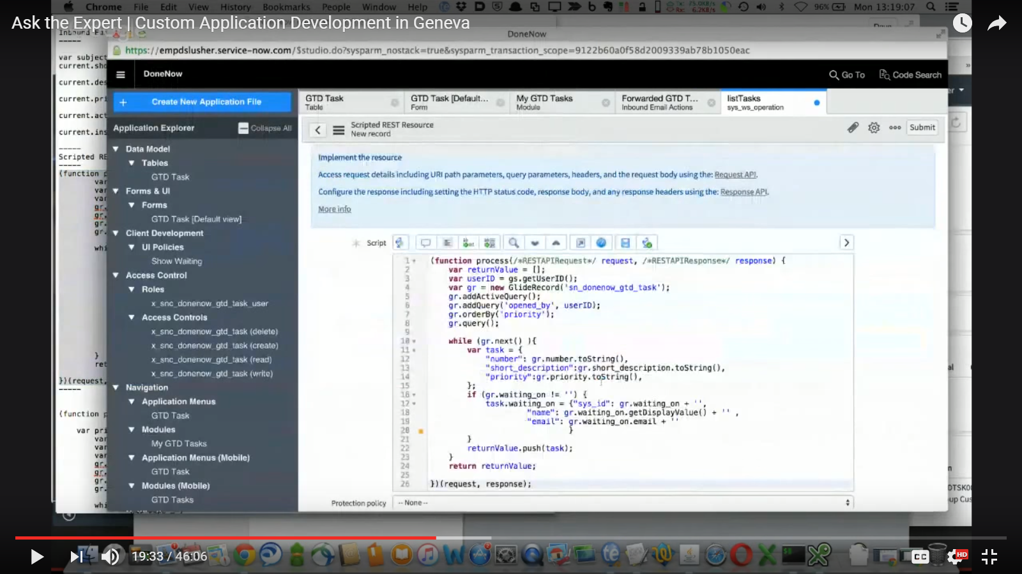

Make sure glide Record is same

Another resource:

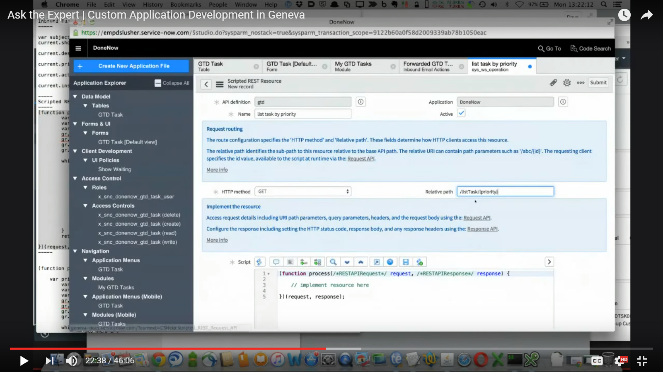

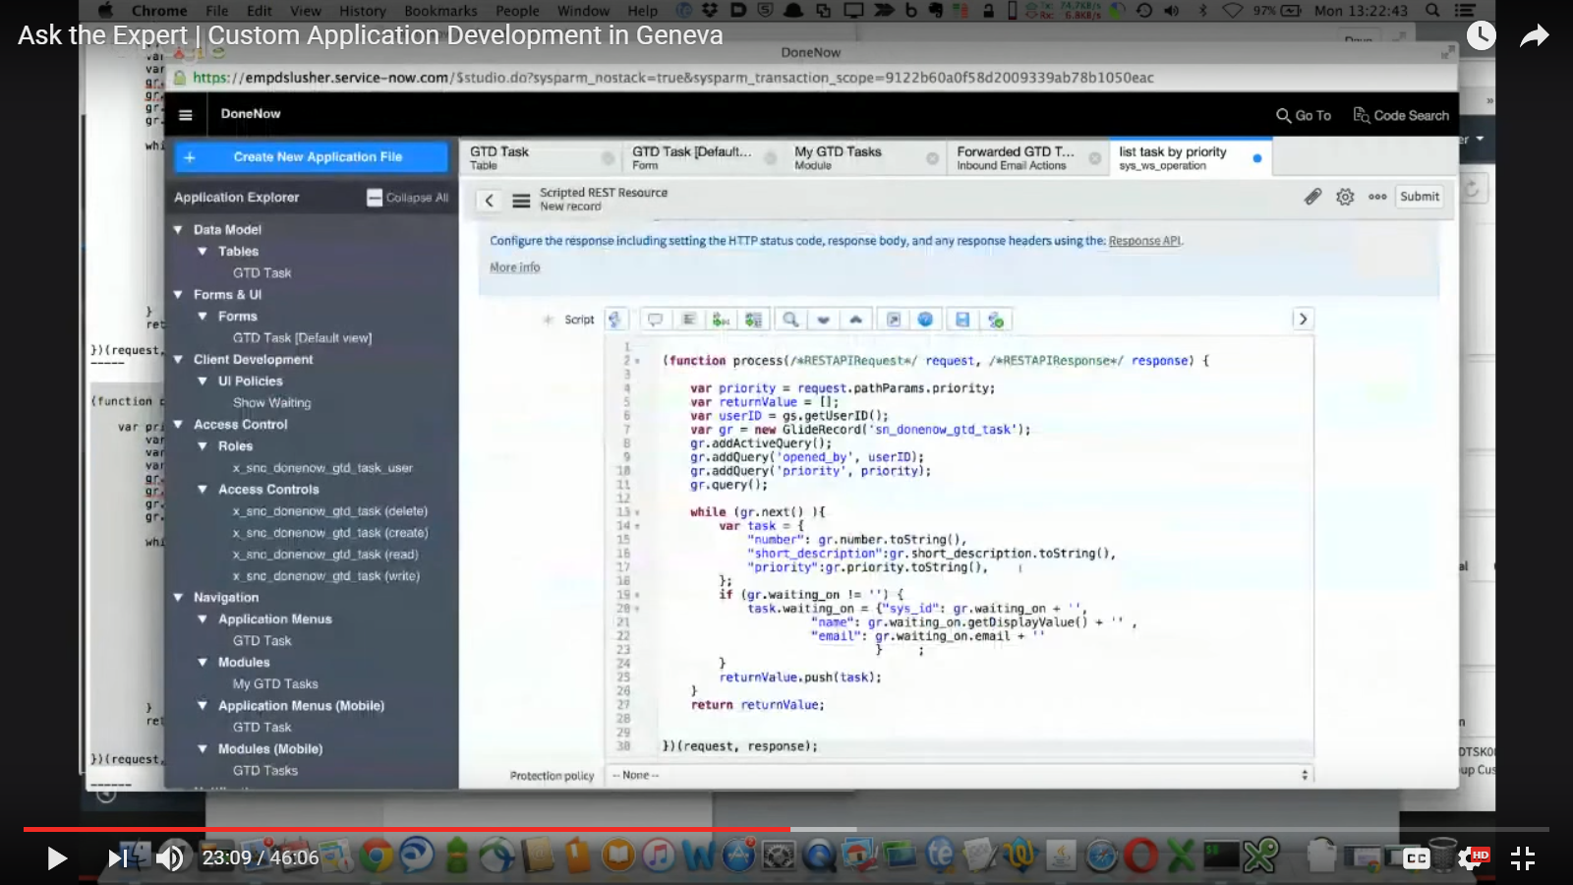

Same as above.

### Notes.

* Add role to yourself for sending emails.
* Contain also itil role in new role
* Right click priority 🡪 show visual task board
* Show how waiting_on can also be seen from profile module
* Explore REST API list
  + Request format: Application/json
  + Receive format: Application/json
  + Authentication: send as another user
* Explore REST API list
  + Insert priority
  + Request format: Application/json
  + Receive format: Application/json
  + Authentication: send as another user

### Project Module.

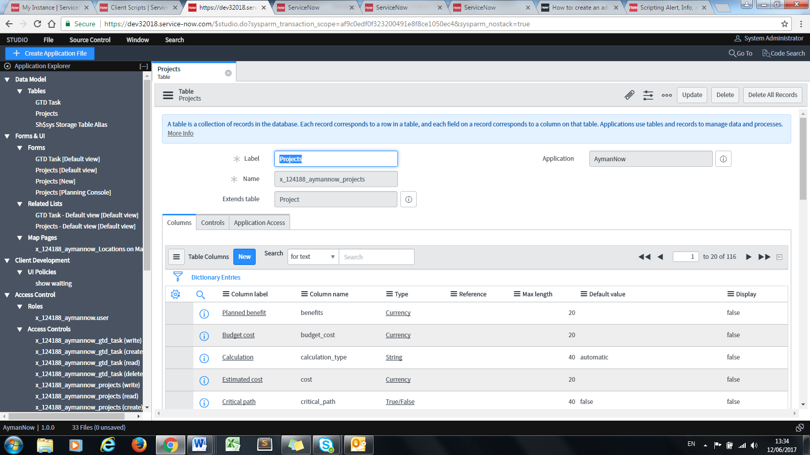

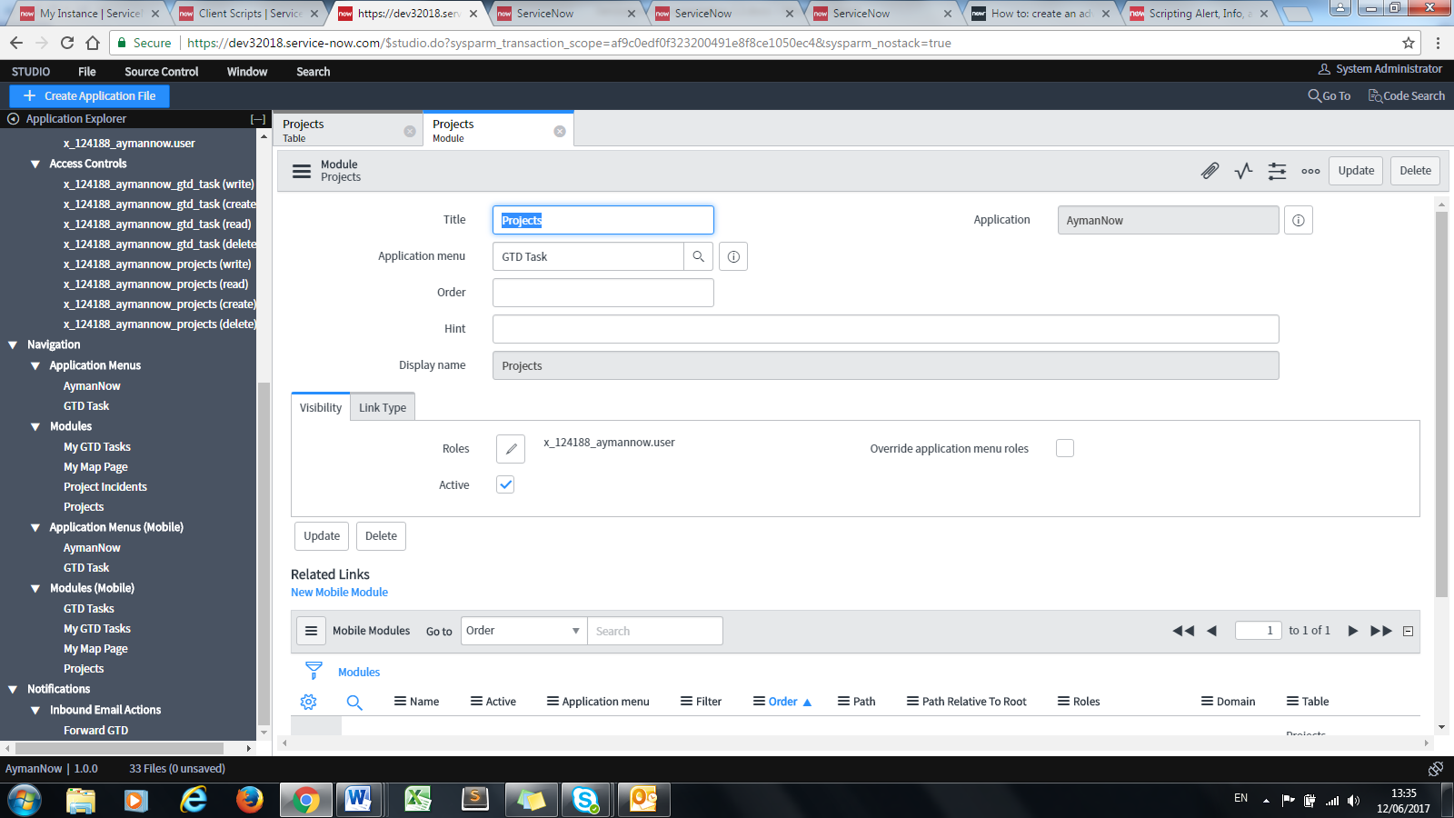



Add location field to new project table/module

### Incident Module.

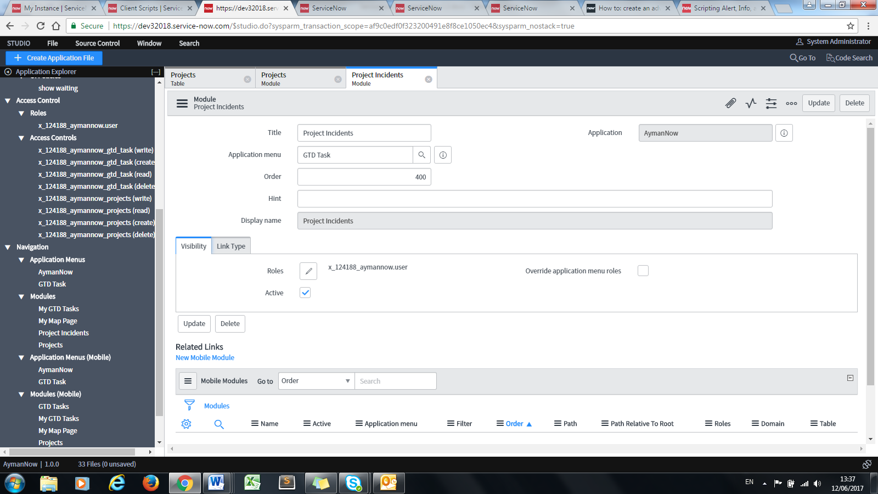

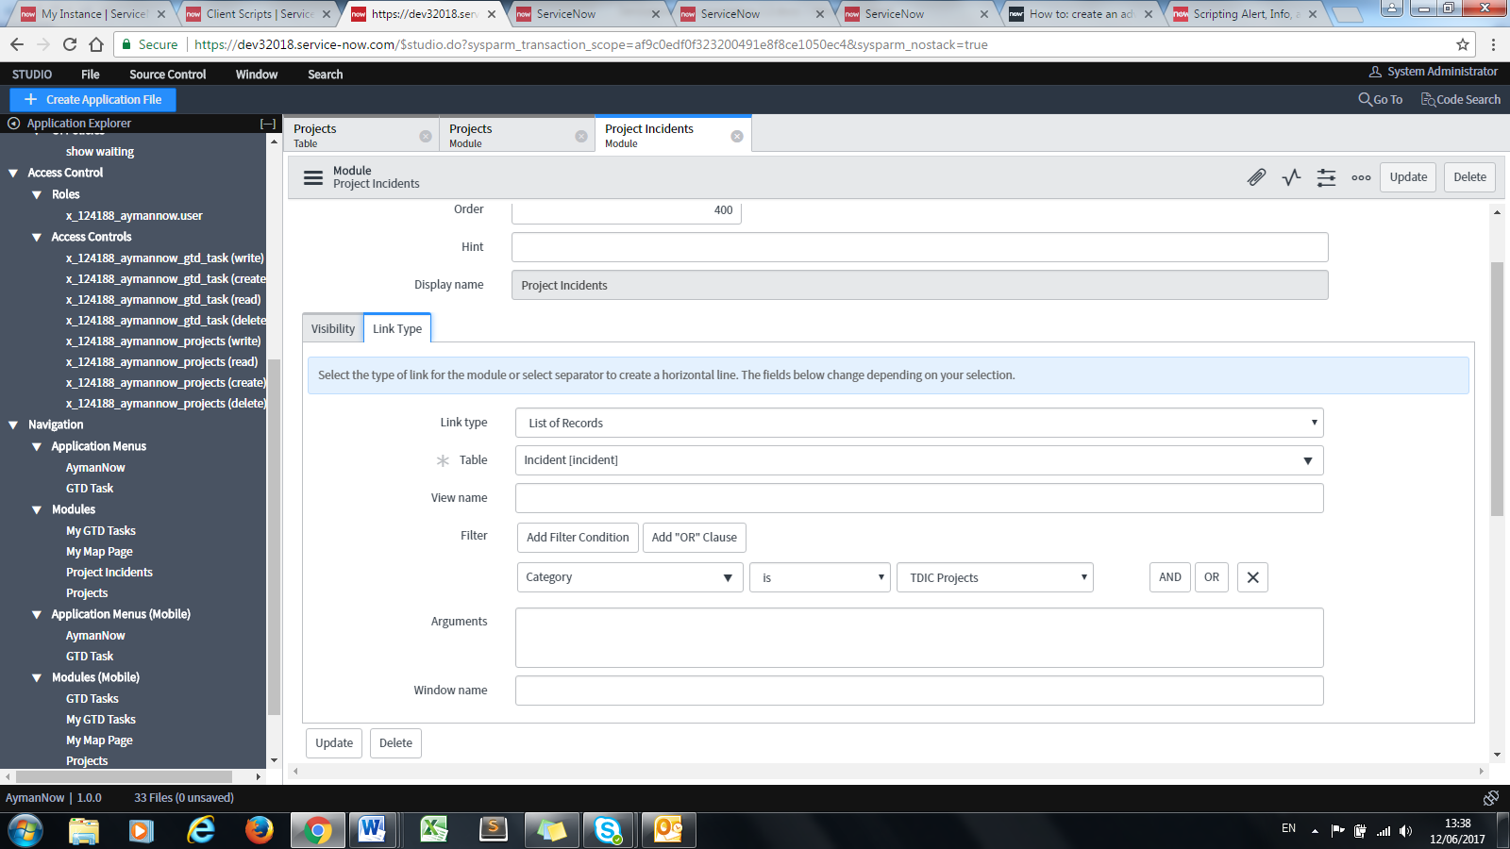

Create Subcategories for TDIC category

### Map Page.

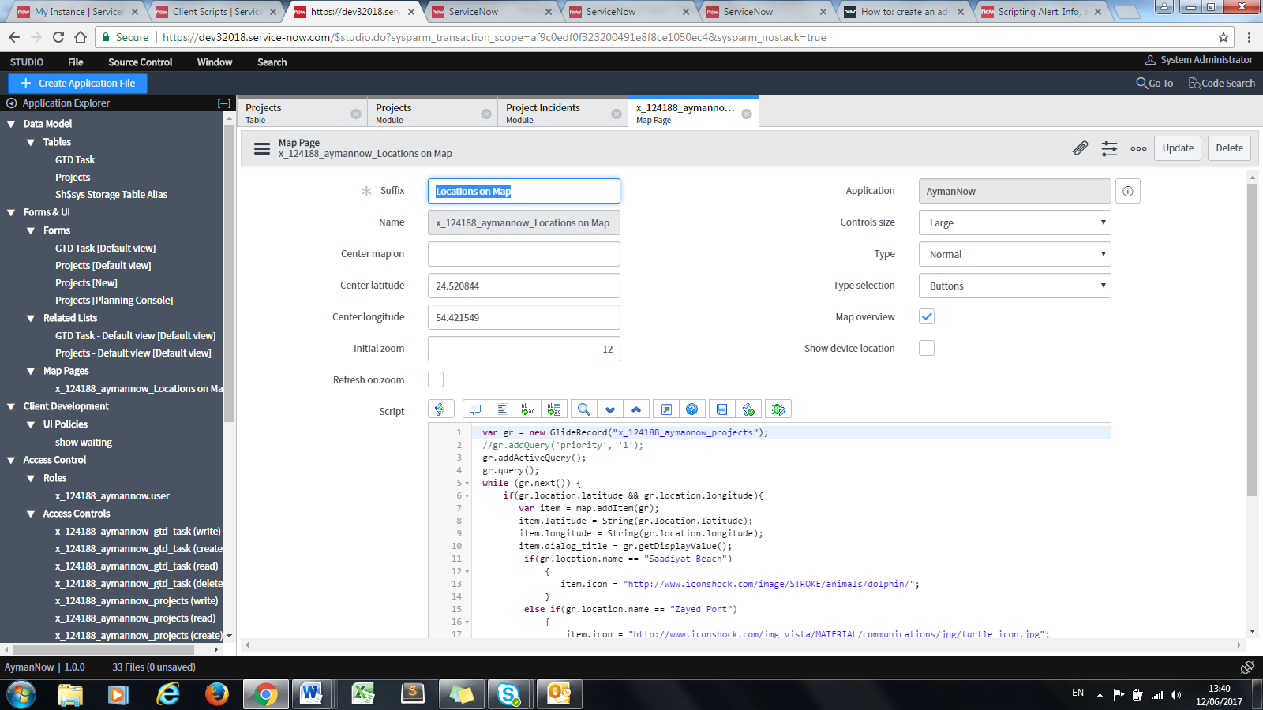

Original script can be found in wiki “map pages”

Add “Center longtitude” & “Center Latitude” because “Center Map on” does not work.

### Map Page Module.

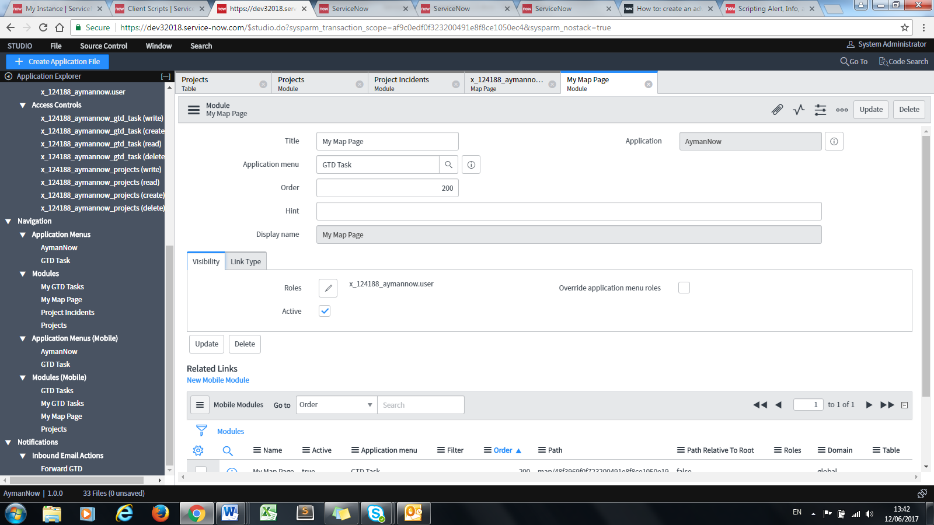

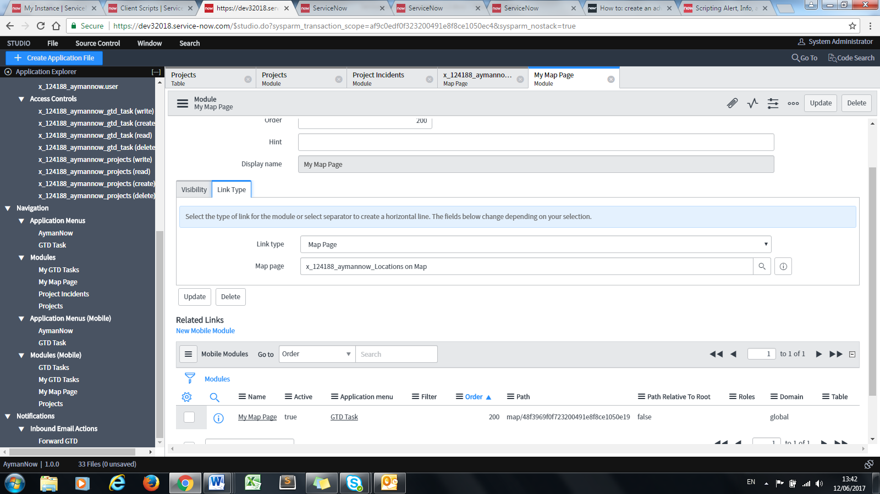

### Map Page Mobile Module.

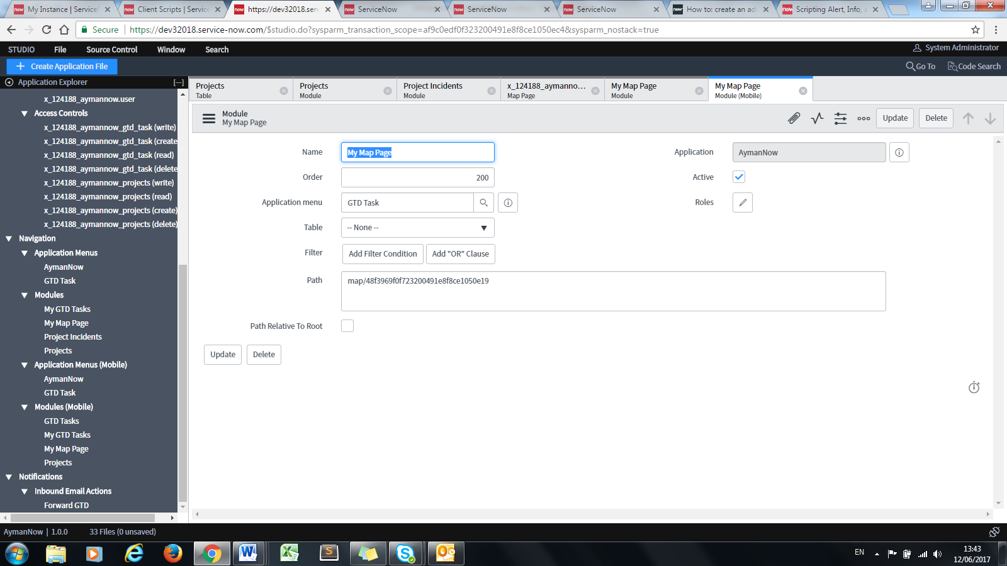

Sys ID = Sys ID of Map Page

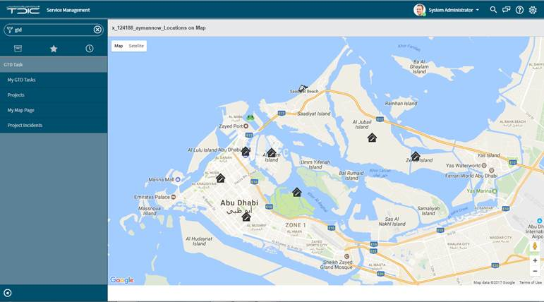

# System Theme Code

## Technical Solution

### Page with System Theme colour codes.

* https://community.servicenow.com/community/service-automation-platform/blog/2017/02/23/helsinki-gray-ui16-theme-for-helsinki